Japan Food Surveyor's Manual

June 2003

Contents
Surveyor Duties 1
Surveyor Responsibilities 1
Figure 1: Sample Survey Street Map 4
Figure 2: Illustration of Photo Log and Area to be Included in Photograph 5
Completing the Japan Food Survey 8
General Instructions 8
Figure 3: Sample Japan Food Retail Store Data Form (Blank) 9
Marking Procedure 11
Heading Items 12
- Front Street Type 15
- Location 16
- Type Operation 20
- Type Business 21
- Lot Size 23
- Hours Open 23
- Sales Room Size (m ) 24
- Number of Clerks 24
- Number of Registers 25
- Special Fixtures 25
- Number Gondolas 30
- Special Services 33
- Fast Food (Cooked On-Site) 34
- Pricing 35
- Store Ratings 37
- Perishable 44
- Proximity 47
18A. Number of Parking Spaces 48
18B. On-Street Parking 51
- Entrance to Lot (Barrier to Traffic Crossover) 54
- Items Offered 55
- Type 4 Transient 56
- MPSI Code 56
- Type Special. 56
- Panel Number 56
- Average Daily Traffic Count 56
- Company Outlet ID 56
- Monthly Sales Volume (Estimated) 57
- Indicate any unusual circumstances about this store. Additional comments 57
Appendix 59
Final Data Screening 59
Manual Traffic Count 60
Survey Wrap-Up 62

CONFIDENTIAL AND PROPRIETARY

Section 1

Surveyor Duties

Surveyor Responsibilities

Your duties are to:
  - Locate and survey every food retail store in your territory, whether open or under construction.
  - Survey all food retail stores. This includes CVS, supermarket, mini­ supermarket, tobacco shops, liquor shop, rice shop, department store, discount store (including ¥100 store), food specialty, bento, fast food (hamburger shop/pizza/doughnut/fried chicken/takoyaki) drug store, and home center.

Below is a table indicating the type of store and if the store must be entered to collect the survey items or if the store can be surveyed by external observation .
    - Must enter the store -The surveyor must go into the store and verify all data.
    - External observation only -The surveyor may verify the data from the exterior of the store.
- If the surveyor encounters a new store then they must enter the store and also perform an exterior survey of the site.

Store Category |  | How to Conduct Survev
CVS  Grocery Store |  | Must enter the store Must enter the store  Must enter the store
Mini-mart
Ichiba (Food shopping center) |  | Must enter the store
Cigarette Shop |  | External observation only
Liquor Store |  | External observation only
Rice Shop |  | External observation only
Department Store |  | Must enter the store
Discount Store |  | Must enter the store
General Store |  | External observation only
Fast Food |  | External observation only
Drug Store |  | Must enter the store
Home Center |  | Must enter the store

CONFIDENTIAL ANO PROPRIETARY

sequential numbers on the photo log sheet (see Figure 2), including the number of each retail outlet. During the survey, use the photo log sheet to keep track of the order in which the pictures were taken and for easy reference when the downloading and numbering pictures is done. See Figure 2 for areas to be included.

NOTE: Be extremely careful when positioning yourself to take the pictures. Place the sun at your back. As soon as you take the picture, verify its quality on the LCD-display at the back of the camera.

NOTE: The camera is set to the ideal configuration, maximizing the number of stores that can be photographed while maintaining the quality of the pictures taken. You should NEVER attempt to modify these settings.

CONFIDENTIAL ANO PROPRIETARY 3

Figure 2: Illustration of Photo Log and of Area to be Included in Photograph

Area to be photographed

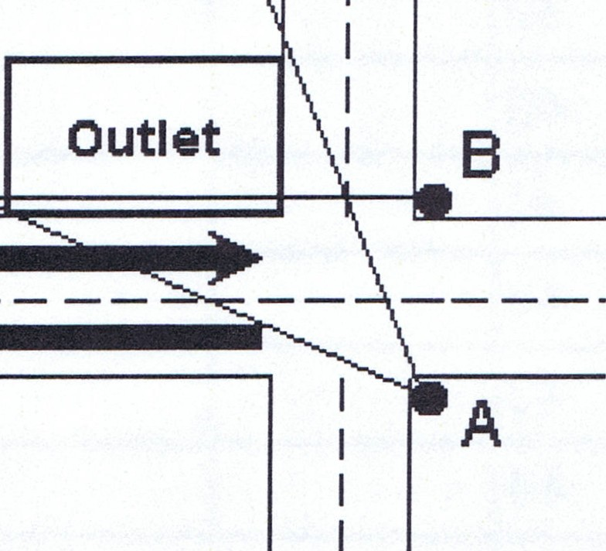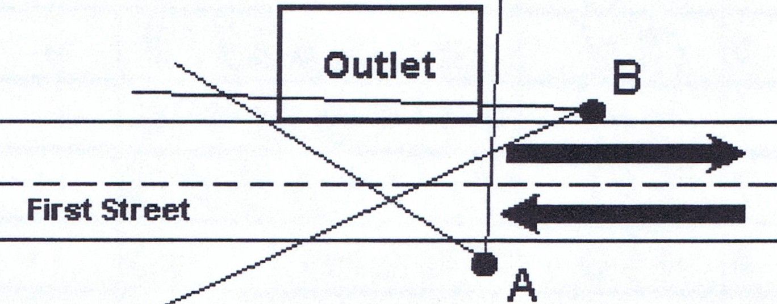
First street

Key
- Photographing Posion Tralfic Flow
Area to be included
'-/ in Photograph

CONFIDENT/AL AND PROPRIETARY 5

Screen each form daily for errors and inconsistencies. It is your responsibility to make certain that spellings of store names and addresses are correct. Be accurate to avoid time-consuming corrections. It is important to compare the site location recorded on the form to the one indicated on the survey map. Discrepancies should be corrected daily. Specifically, check to be sure that street names, site direction on streets (N, NW, etc.), and site locations (corner, T-Junction, etc.) recorded on the survey form are identical to those plotted on the map.

Supplies:

DESCRIPTION | QUANTITY
Survey Manual | 1
RO Data Card Pads | 2
Photo Log Pads | 1
Daily Status Report Pads | 1
Red permanent marker | 3
Clioboard | 1
Pad of writing paper | 1
Name Stamo | 1
Pack of four Post-Its (small) | 1
Digital Camera (with manual) | 1
SmartMedia Photo memory card (32Mb) | 1
GPS unit (with Quick Start Guide) optional | 1
Traffic tally counters | 2
Rechargeable batteries | 4
Battery charger | 1
Regular batteries | 4
Calculator | 1

CONFIDENTIAL AND PROPRIETARY 7

Figure 3: Sample Japan Food Retail Store Data Form (Blank)

Card Type ITO Territor rn Outlet[[D Intersection I I I I I Date I I I I I I I
1 2 3 4 5 6 7 8 9 10 11 12 Yearo Montho Day Store Name I I I I I I I I I I I Chain Code I I I I I I I
13 14 15 1fl 17 18 19 20 21 22 23 24 25 26 27 28

Address! I I I I I I I I I I I I I I I I I I I Primary Street Name ------- Lat: N [I]:[I][IJ
29 30 31 32 33 34 35 3fl 37 38 39 40 41 42 43 44 45 4fl 47

Secondary Street Name _ Long: E [II] [I][I]1 Surveyor
1. Front Street Type  000000001-48 (PRINCIPAL)  DDDDDDDo2 (PRIMARY)  OOODDDOo3 D(SECONDARY)  DDDDDDDo4 (MINOR ROAD)  000000005 (OTHER) | (NW.etc) rn  2. Location 49 50 3.Type Operation 4. Type Business  oOther Independent 01-59 CVS 01-60  O (NW.W .etcl rn Voluntary o3 Market o4  51 52 Franchise o2 Supermarket o2  Mini Supermkt o3  T-Intersection  r53 n54 Tobacco o5  Liquor Shop 06  Company o4 Rice o7  oCorner  INW.NE.etc r55n56 Other o5 Department St 08  Discount o9  Under Const. 06  010  oShopping Center General  INW.E.etcl Fast Food 011  DResidential Area rn Home Center 013  57 58 Drugstore 012 |  |  | 5. Lot Size  Front Depth  < - 10 ...oo 0  1-61 1-  62  10 -20 ...oo 0  2 2  21 -50 ...oo 0  3 3  51-100 ...oo 0  4 4  > - 100 ...oo 0  5 5
6. Hours Open  rWeenkdays orSunnday rSunnday  13 14 15 16 17 18  Day Closed O.None  D 1.Mon  2. Tue  19 3.Wed  THU  4.  5. Fri 6.Sat  7.Sun |  | 10. Special Fixtures  r31n32  DNo of Doors of Freezer  r33 n34  DNo of Doors of Refrigerator  oOpen Case Width oo rn  35 36 | 12. Special Services (multi-check)  Multimedia Station o 1-49 Utility Payment o 1-50 Other (ATM,etc.) o 1-51
13. Fast Food (Cooked on site) Nikuman/Oden o 1-52
Lunchbox/Riceball o 1-53
Fountain Drinks/Slush o 1-54
Hamburgers/Hotdogs o 1-55 Fried Chicken/Sandwiches
11. No of Gondolas
r37n38
DRice
DTobacco w
41 42
Dliquors []]
43 44
DBento/Riceball/Sushi []]
45 46
...,.,,....,..._ []]
(Other)
47 48
[]]
(Other)
7. Sales Area (D)
DJ 0 I I I I
20 21 22 23 24
14. Price (Lowest Price regardless of NB or RB)

10-egg pack, M or L I I I I
DEggs

57 58 59
DMilk I I I I
1L 60 61 62
1 Serving I I I I
oBread
63 64 65
8. No of Clerks
I I I I
25 26 27
9. No orf Rengisters
28 29 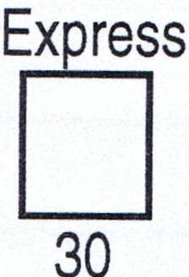

CONFIDENTIAL AND PROPRIETARY 9

Marking Procedure

Circles should be marked as shown:

- Boxes may require numbers only, letters, or combinations of letters and numbers. Numeric entries should be right-justified . (Make your entry as far to the right as possible):
Example: I 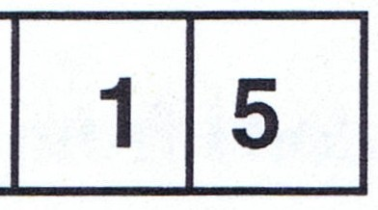
- Letter and letter/number combination entries are left-justified (begin in the box farthest to the left):
Example: IC I L I IE I N I T I
Example: I 1 I - I 1 I 9 I I S I H I I I M I B I A I S H
- Place only one number or letter in each box.

- Use RED-PEN for all entries.

CONFIDENTIAL AND PROPRIETARY 11

Chain Codel I I I I I I
23 24 25 26 27 28

Chain Code: Leave Blank

NOTE: Chain codes are a three-letter abbreviation and are assigned and input during the data entry process.

Ad ess I I I I I I I I I I I I I I I I I I I I
29 30 31 32 33 34 35 36 37 38 39 40 41 42 43 44 45 46 47

Address: Enter the address of the store. Use Furigana if necessary.

Primary Street Name
Secondary Street Name
--------

Primary Street: Enter the name of the street that the store is best designed to serve. This is usually the street with the heavier traffic, but there may be occasions when the store faces or best serves the street with less traffic . In these cases, the street with less traffic should be designated the primary street.

NOTE: If the store is located in a shopping center, the primary street is the one best designed to serve the entire center.
Secondary Street: If the store is accessible from or is adjacent to two streets, enter the name of the secondary street. If the store is close, but not adjacent to another street, write the location of the store in regard to the other street

I D  ---  - -- - - - --- - | I
 | Rl EE_T-
PRIMARY & en
SECONDARY m
"0 D
:z
0
L -
en
PRIMARYSTREET - -;rj - - - - - ---
m m
-I

PRIMARY NEAR PRIMARY &
SECONDARY SECONDARY

D D
>-- >-- -- -- L -
PRIMARYSTREET - - --------
I I

CONFIDENTIAL AND PROPRIETARY 13

- Front Street Type

Mark the circle that best describes the type artery on which the store is located:

1. Front Street Type

3;!j$K*Jll: . . 01-48
(PRINCIPAL)

il!t1J!j$K*11..02
(PRIMARY)
m111T;tN11 03
(SECONDARY)
-®'.+Jll:Im . . 04
(MINOR RO.AD)
.:t O){!!! 05
(OTHER)

Principal: The store is located on a major highway or road leading from one city or prefecture to another. Example: National road.

Primary: The store is located on a less heavily traveled road that connects intraurban areas and does not cross prefectural boundaries.
Example: Prefectual road.

Secondary: The store is located on a linking street between primary or principal roads that carry traffic through a city. Example: City road.

Minor Road: The store is located on a less heavily traveled street that carries traffic through a city. Example: Gathering or collector road.

Other: Any type artery not defined above. Example: Expressway link; roadway inside an airport or amusement park.

CONFIDENTIAL AND PROPRIETARY 15

Other: Sharp triangular lots/Y-shaped intersections Example:
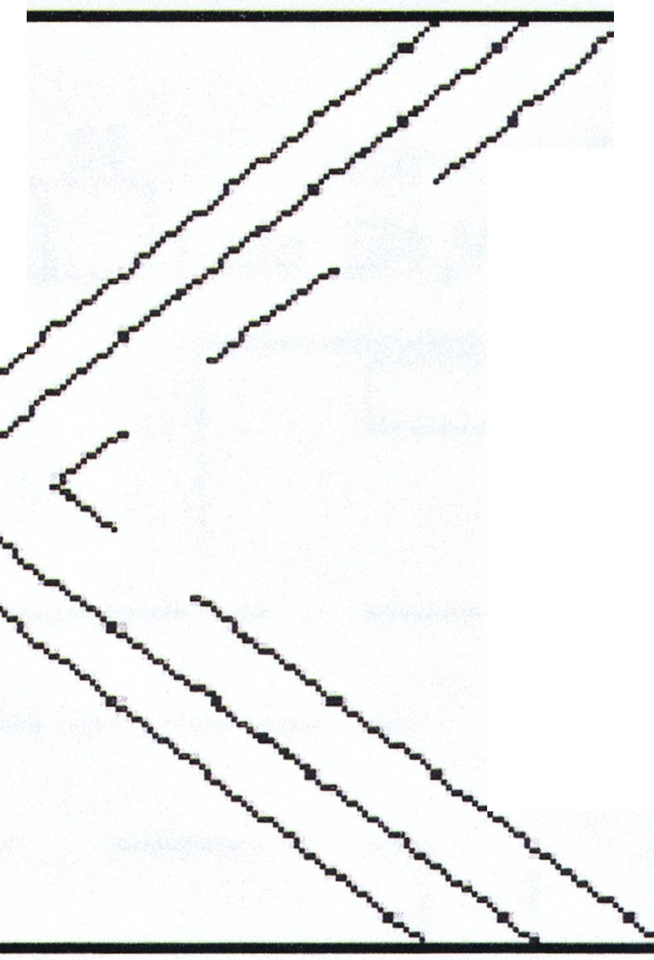V-shaped
[Spoif y)
DIRECTION [[II]
EJ

Other: Parallel streets Example:
Parallel N
:5
(Speciity)

DIRECTION
I N l s l

1--- -----------------

I I
CVS
.....- -----------------

CONFIDENTIAL ANO PROPRIETARY 17

Shopping Center: No direct street access, such as an outlet on the grounds of a shopping center or shopping mall. Use the location of the facility whose grounds must be entered to reach the outlet. An outlet at the corner of the city street or the shopping center driveway is not a shopping center location.

57 58
Shopping Center I S IWI
Secondary Street
I
Primary Street
I
I I
ACCESS: B I

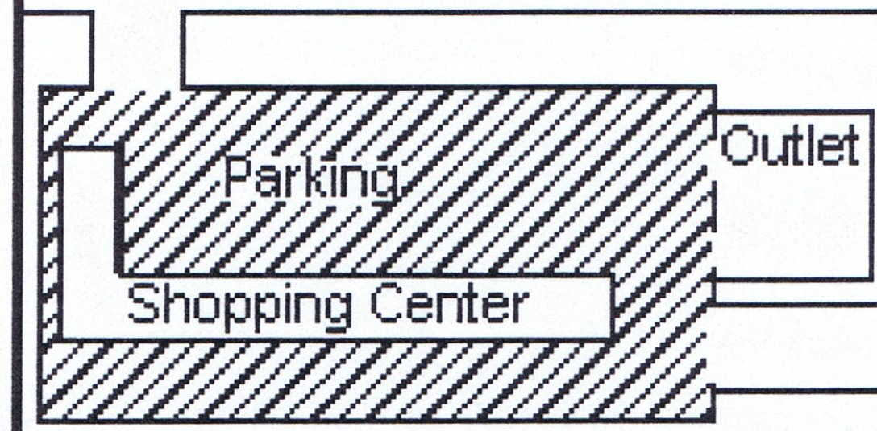Residential Area: The store is located within a housing complex. This also refers to any site that is not other, T-junction, corner or shopping center.

 | I I
CJ  CJ CJ CJ |  | CJ CJ
CJ ] [ CJ re CJ ] [ CJ

CJ  CJ | CJ CJ | CDJ
 | I I

CONFIDENTIAL AND PROPRIETARY 19

Type Business

Mark the appropriate circle.
4. Type Business
CVS 01-60
Supermarket 02
Mini Supermkt 03
Department St 08
Discount 09
General 010
Fast Food 011
Drugstore 012
Home Center 013

Market | 04
Tobacco | 05
Liquor Shop | 06
Rice | 07

CVS: A convenience store whose principal business is providing a limited food line with time saving features. The type of operation is typically franchise or voluntary. The average building size is approximately 100 or 200 square meters. Business hours are usually 7 a.m. to 11 p.m. or later; open seven days a week.

Supermarket: A supermarket/grocery store that carries approximately 6,000 to 12,000 different items. The type of operation is typically individual or franchise. The building size is usually at least 700 square meters. Business hours are normally 10 a.m. to 6 p.m.; the store is usually closed one day per week.

Mini-Supermarket: A mini grocery store that carries approximately 6,000 different items. The type of operation is individual. The average building size is approximately 400 square meters. Business hours are normally 10
a.m. to 7 p.m.; the store is usually closed one day per week.

Market: The outlet is a local community market. A cluster of individually owned shops that create a local neighborhood market.

Tobacco: A store whose primary business is the sale of tobacco products.

Liquor Shop: A store whose primary business is selling alcoholic beverages for consumption off premises.

Rice: A store whose primary business is the sale of rice products.

Department Store: A store that offers multiple lines of products and is divided into corresponding departments. The other departments do not need to be on the same floor as the food products.
CONFIDENTIAL AND PROPRIETARY 21

Lot Size

5. Lot Size

Front Depth

< - 10 ···O O
1-61 l-U2
10 -20 ...o 0
2 2
21 -50 ···O 0
3 3
51 -100 ...o 0
4 4
> - 100 ...o 0
5 5

Estimate the frontage and depth of the lot and mark the appropriate circles. To simplify the estimation of the sizes, the surveyor should pace the front and depth. You should measure your pace and use this as the basis for the determination of the required lengths. Lot Size is the total size of the property developed or perceived by the customer as used for the sale of products.

    - Pace - Measure frontage and depth pacing from one end to the other.

    - Cars - Visualize how many cars will fit into the sp e you are estimating. The average automobile length is 3.5 meters

Hours Open

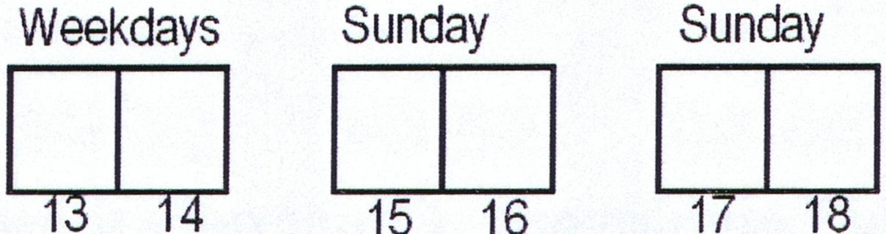6. Hours Open

Day Closed

O. None 1.Mon
D
2. Tue
19 3. Wed
4. THU
  - Fri
  - Sat
7. Sun

Weekdays: Enter the average number of hours that the store is open on weekdays (Monday through Friday).
NOTE: Round off half-hour increments to the next higher whole number.
For example, list 8.5 hours as 9 hours.
CONFIDENTIAL AND PROPRIETARY 23

Number of Registers

  - No of Registers
Regular Express
DJ D

28 29 30

Regular: Enter the number of regular checkout lanes. There should be at least one lane (place) to pay for customers' purchases.

Express: Enter the number of express checkout lanes. If a register is located at the service counter this qualifies as an express register.

1O. Special Fixtures

_ 10. Special Fixtures No of Doors of Freezer

No of Doors of Refrigerator Open Case Width

31 32

DJ
33 34

DJ
35 36
DJm

# of Freezer Doors: Enter the number of frozen food coolers for both horizontal and vertical freezers.

# of Refrigerator Doors: Enter the number of food, soft drink and beer refrigerator doors for both horizontal and vertical refrigerator. Food items included in these refrigerator doors could be milk, yogurt, butter, packaged lunch meat, pre-packaged sandwiches, cheese, box ice cream, cold snack items, etc. Soft drink refrigerator doors include all type of sodas and juices. Beer refrigerator doors include all brands of beer and wine coolers. Include walk in and reach in freezers, refrigerators/coolers .

NOTE: Sometimes refrigerator orfreezers items are stored in units that are openfront, reach in units and do not have doors. If this is the situation then count each 90 cm of storage area as 1free zer or refrigerator door.

CONFIDENTIAL ANO PROPRIETARY 25

Short Open Case

Some open case compartments are shorter and might be free standing in the store. Compartments that are less than 1.7 - 2 meters tall should be measured and divided by half when inputting the meter measurement. Inthe photo below, the open case width is 120cm. However, because the height is less than 1.7m, divide
120cm by 2 and round to the nearest meter. Inthe example below, 120cm/2 =
60cm, so input lm as the Open Case Width.

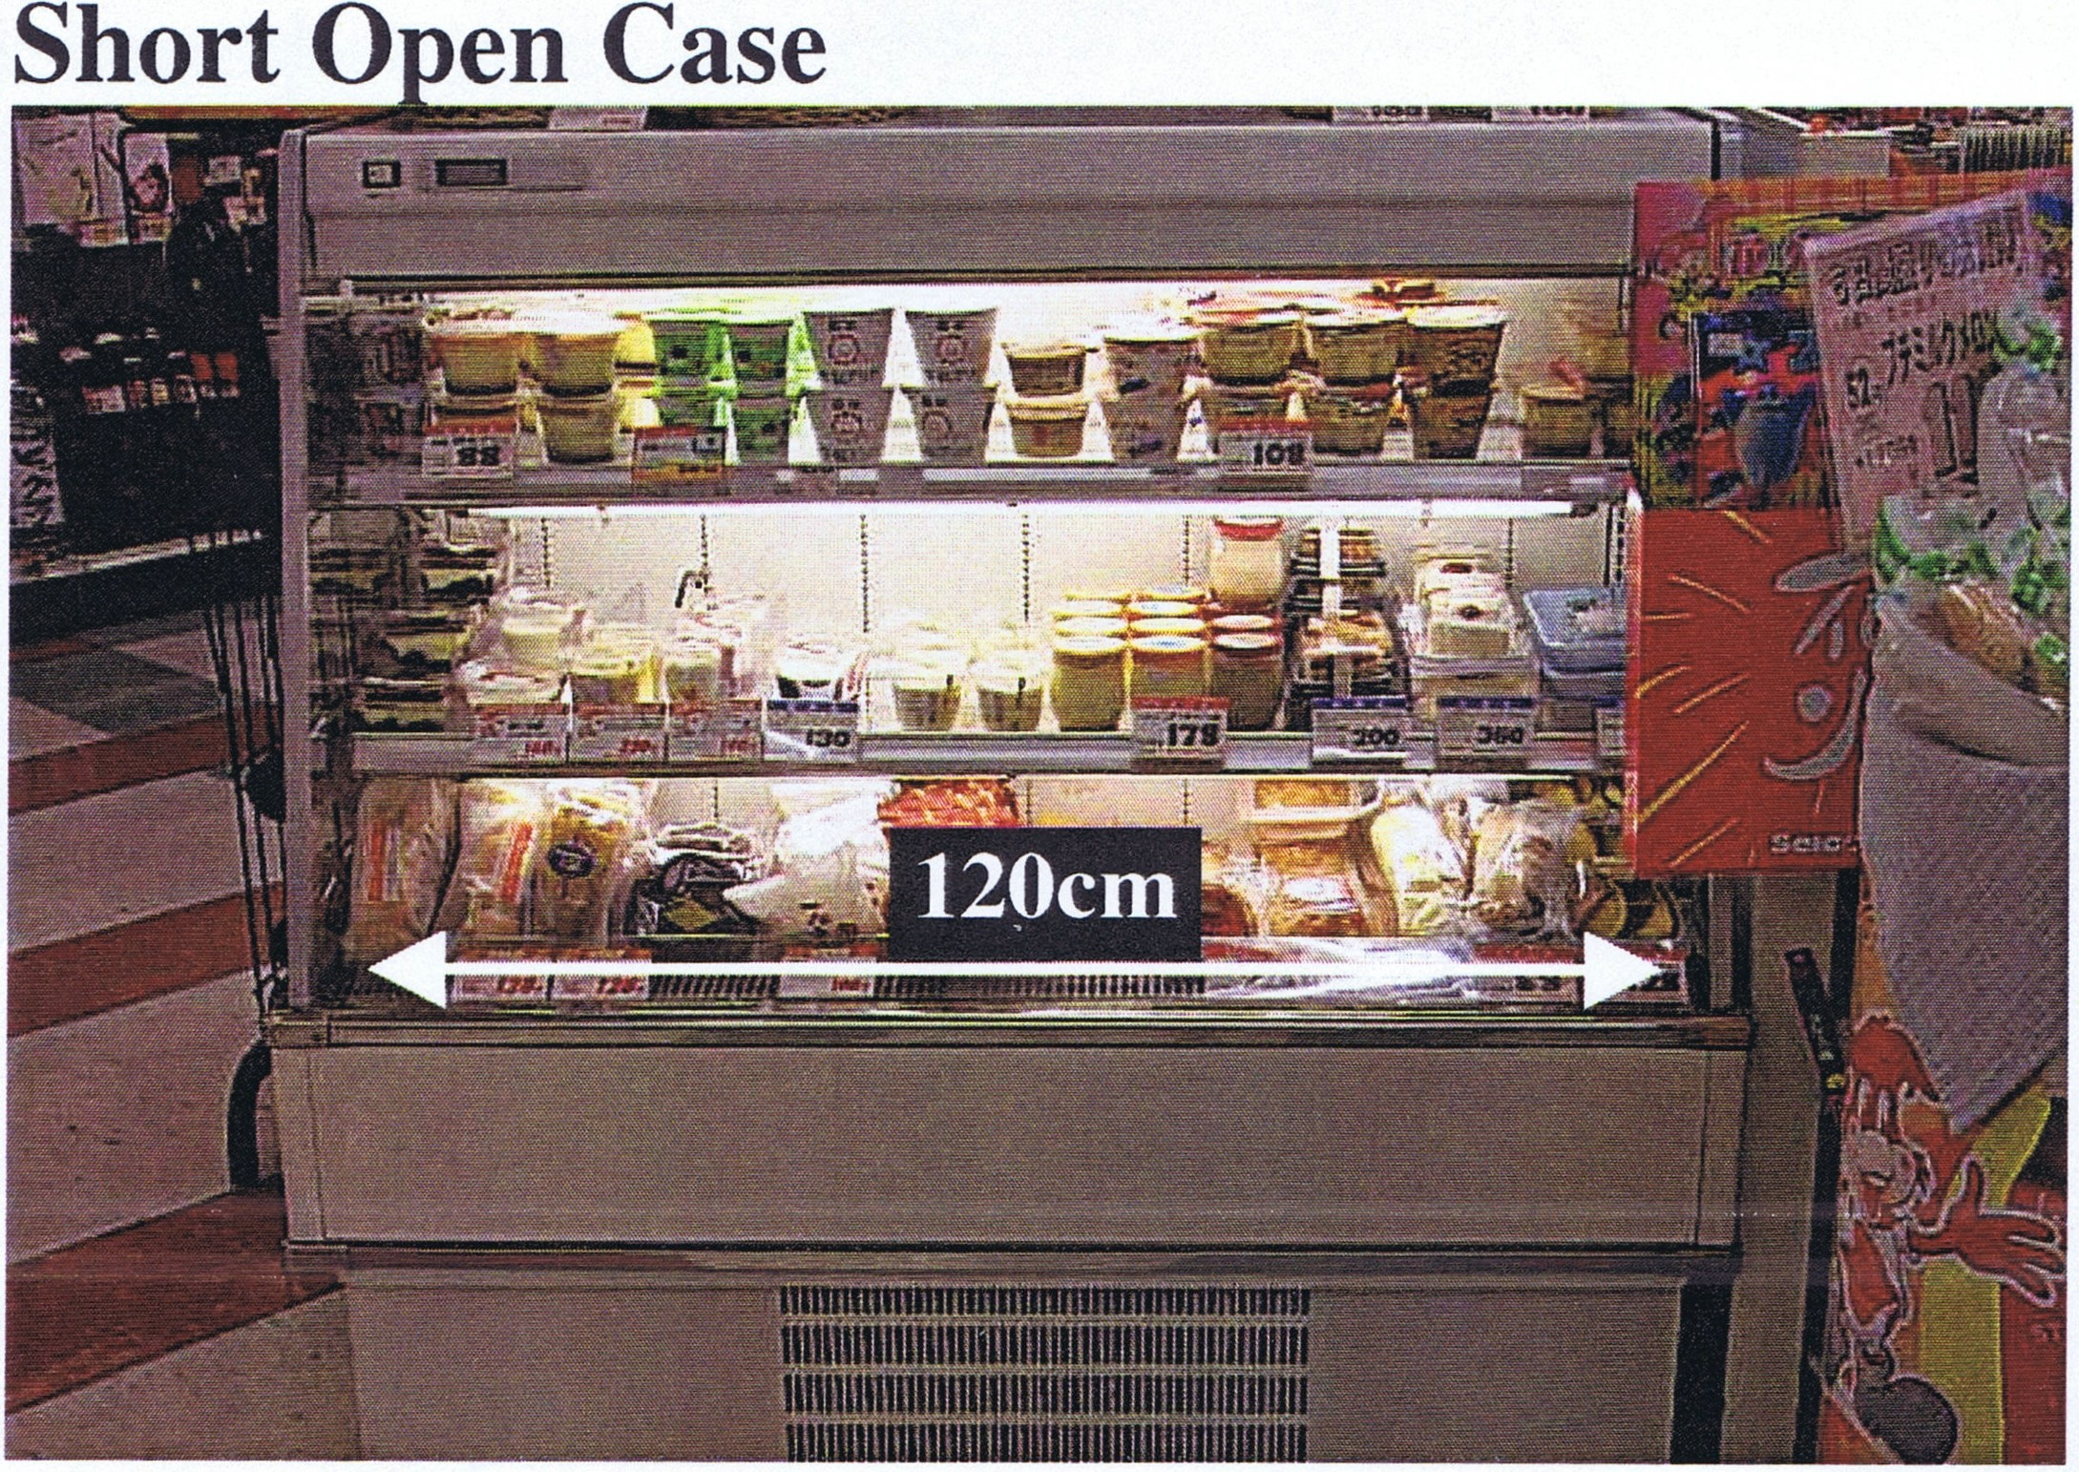

CONFIDENTIAL AND PROPRIETARY 27

Flat (Ground) Freezers - Double Sided

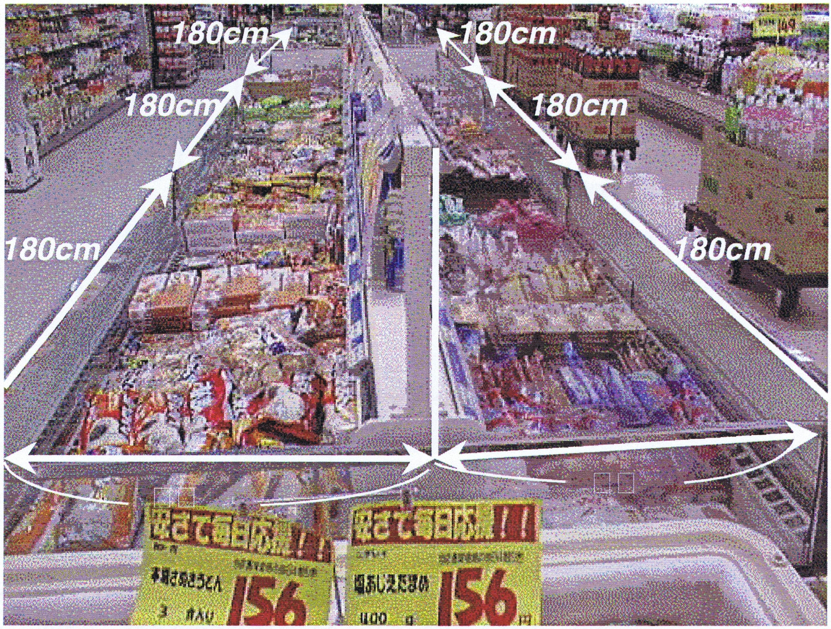
In this photo, there are six 180-centimeter cases.
(180cm ..;. 90cm = 2).

Freezers = 12

Flat (Ground) Freezers - Single Sided

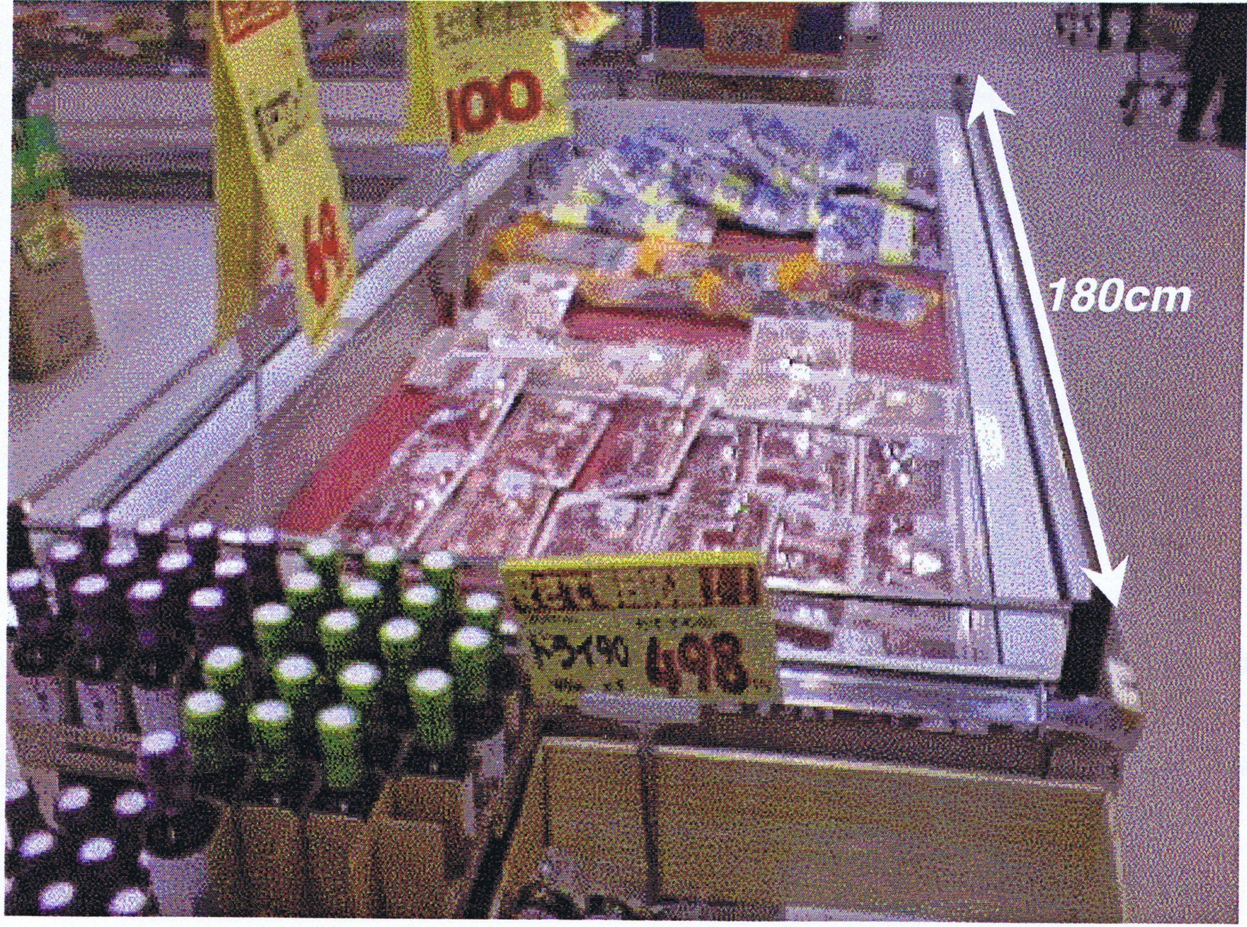

Freezers =2
180cm + 90cm = 2

CONFIDENT/AL AND PROPRIETARY 29

Rice

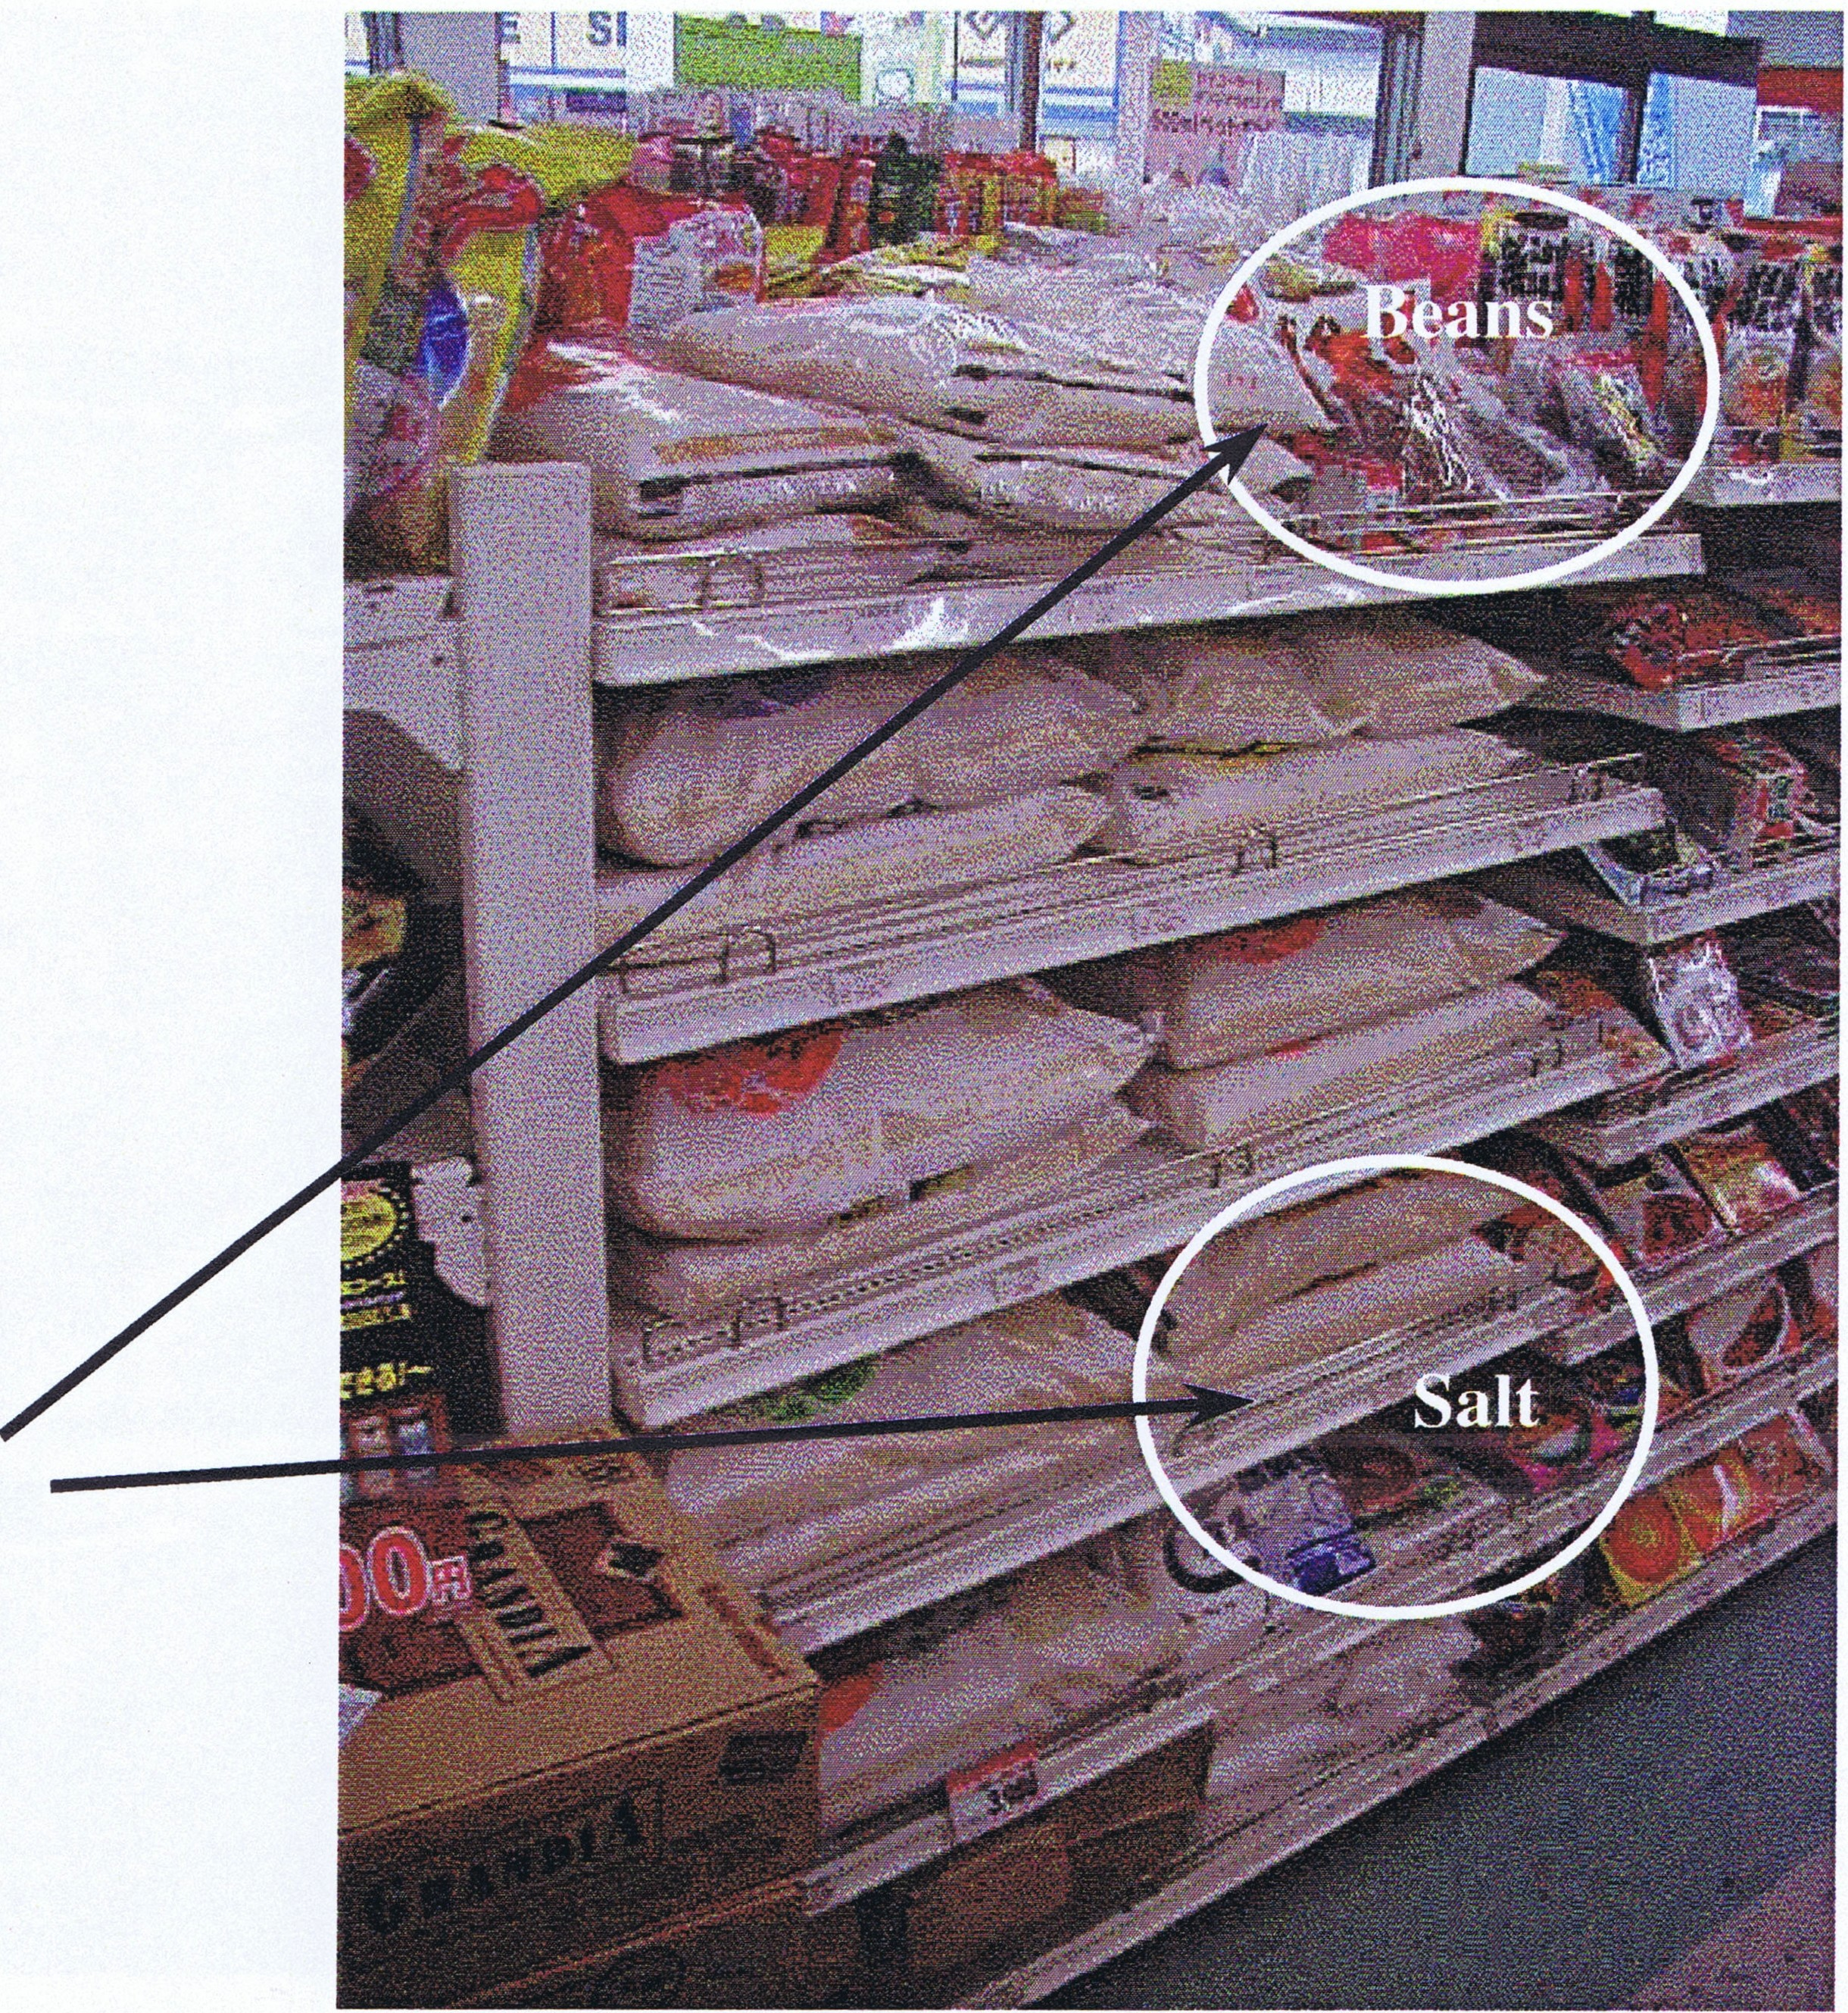
Number of Gondolas Rice =1

Although there are other items in the same gondola still count it as '1' because the gondola predominantly contains rice.

Tobacco

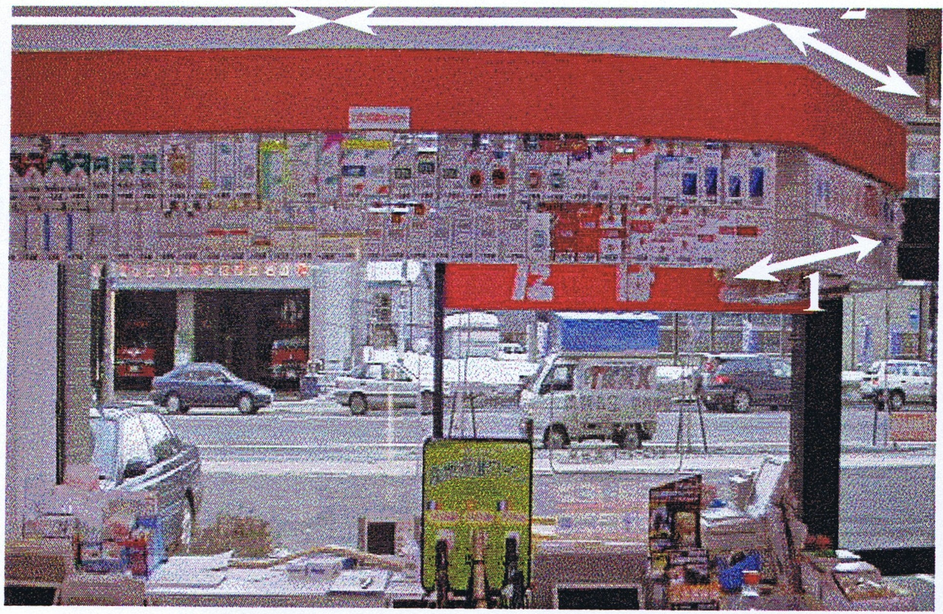

Usually this does not count, UNLESS there is no tobacco elsewhere (in which case, put '1')

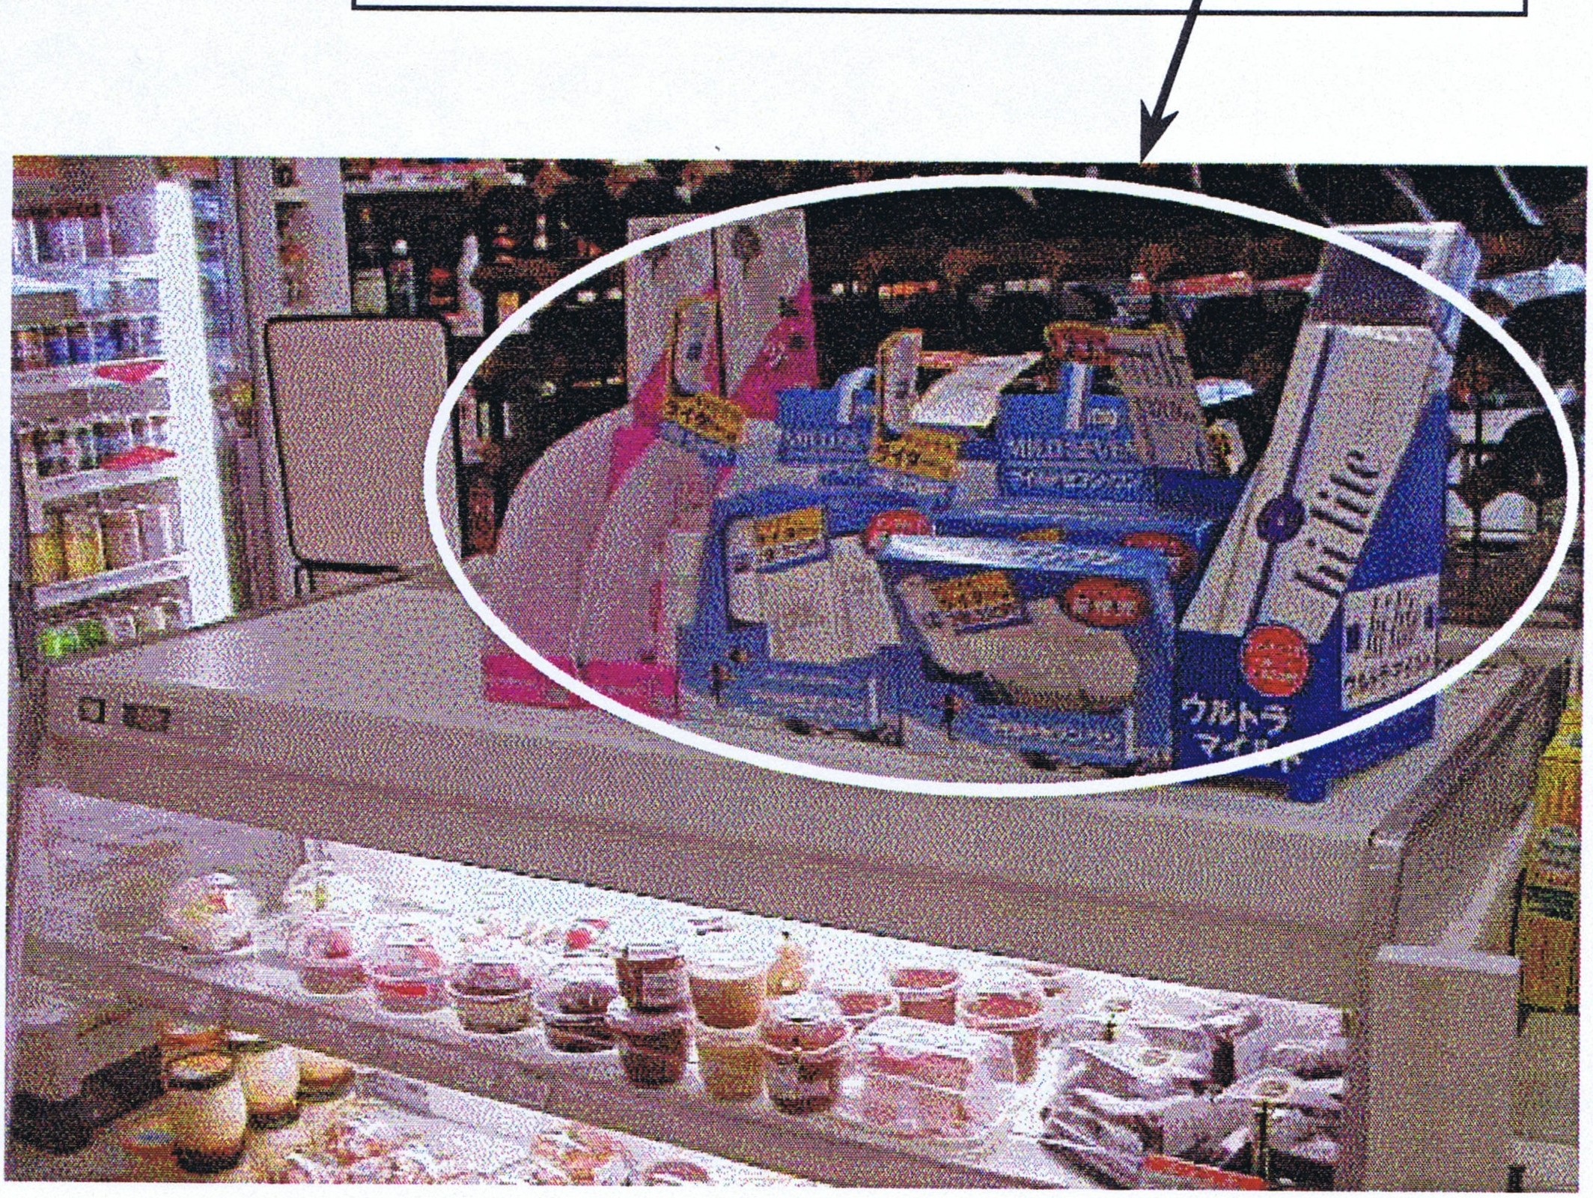CONFIDENTIAL AND PROPRIETARY 31
Number of Gondolas Tobacco = 2

12. Special Services

12. Special Services (multi-check)
Multimedia Station 0 1-49
Utility Payment 0 1-50
Other (ATM, etc ) 0 1-51

Mark the appropriate circle.
Multimedia Station: Check if the store offers a multi media station. Multimedia stations typically sell movie/museum/event tickets. They might offer hotels at a discount, airline tickets or membership information.

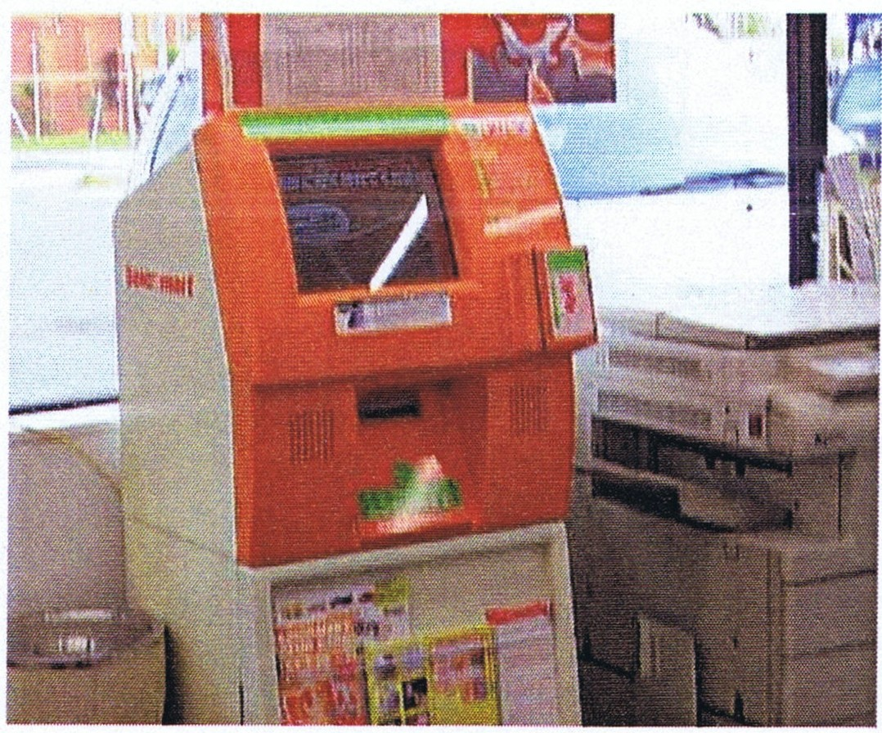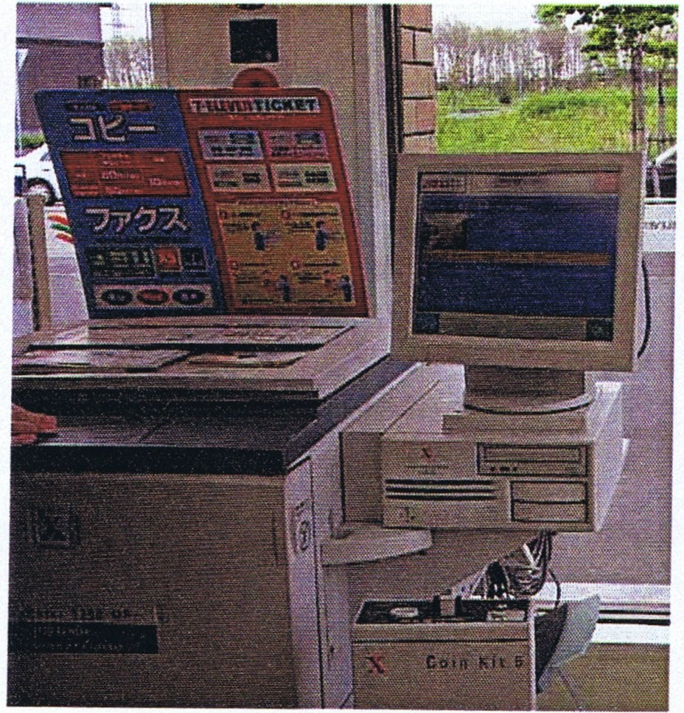Multimedia Stations

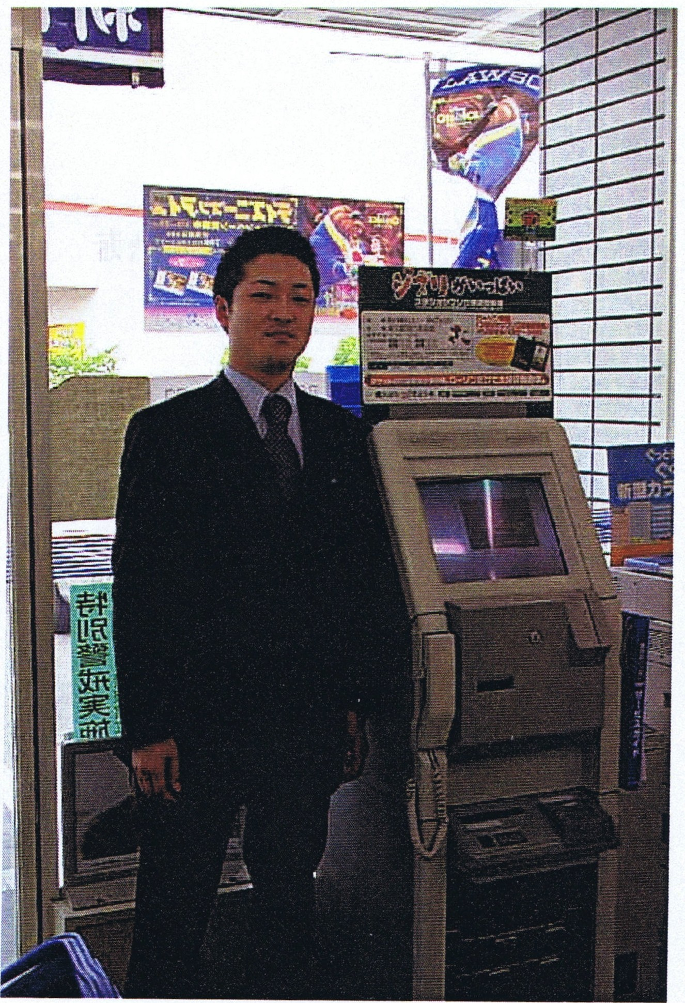

Utility Payment: Check if you can pay utility bills at the store.

Other (ATM): Check if the outlet offers other special services, such as an automated teller machine.

CONFIDENTIAL AND PROPRIETARY 33

14. Pricing

14. Price (Lowest Price regardless of NB or RB)

Eggs
10-egg pack, M or L

Milk
1L

Bread
1 Serving

57 58 59
I I I I
0:0

I I I I
63 64 65

Enter the store's usual price for the foods listed. Do not use sale prices.
Eggs: Enter the store's lowest usual price for a 10-count package medium or large eggs.

Milk: Enter the store's lowest usual price for a one-liter carton of whole milk. Do not include low fat milk.

Bread: Enter the store's lowest usual price for one package (approximately 6 slices) of white bread.

CONFIDENTIAL AND PROPRIETARY 35

Store Ratings

- Store Rating o NIA
  - Below Avg
  - Average
  - Above Avg
flccessibility
Visibility Appearance
(Walls, lighls, rLBl etc.)

Cleanness
(trash can, back counter, etc.)

Clerk Service

Price Card Display (incl. 'labeler')
013
014
015
016
017
Orn
Apparatus
Neatness of Item Display

Out of stock
(Walk-in fridge, etc.)

Inside Promotion
019
020
021
022

Use the following ratings for this item: 0 - None
1 - Below Average
- - Average
- - Above Average

In this item, you will be rating specific store characteristics based on the following criteria. These ratings require a value judgment . The ratings given should be relative to the stores in the study area. Use extreme care in rating characteristics . Be objective and consistent. Most importantly, use 2 - Average ratings unless you have a good reason for giving a higher or lower rating.
NOTE: Avoid overrating your own stores.

Each of these characteristics can receive a rating of 1 - 3.

Keep in mind the following typical market area rating distribution for accessibility, visibility, or appearance:
Below Average: No more than 20% of outlets
CONFIDENTIAL AND PROPRIETARY 37

  - A continuous driveway entrance on all streets.
  - Large lot size.

BELOW AVERAGE ACCESS (1)

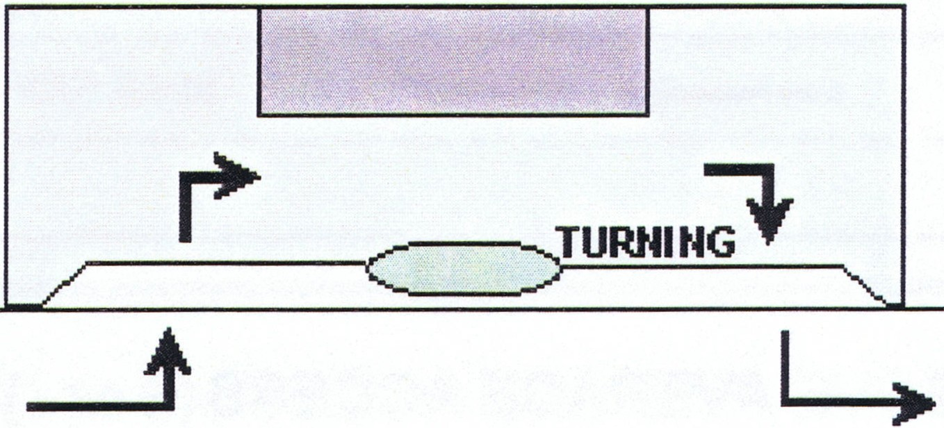Traffic interference

NEAR SIDE LANE

High Speed Traffic

Busy/Fast Main Road - Sharp Turning

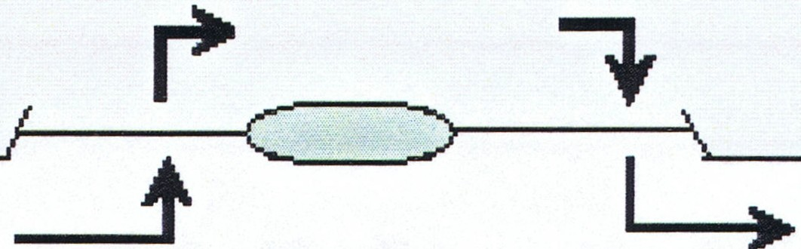---•)Ii NEAR SIDE LANE

Poorly Positioned Traffic Signs - Below Average Rating

Outlets situated near traffic control signs/lights may have their access points frequently/continually congested by stationary traffic.

ENTRANCE AND EXIT FREQUENTLV
OBSTRUCTED BY TRAFFIC DETAINED AT LIGHTS

PRIMARY ST

1(

TRAFFIC CONTROL LIGHTS
I I I I I

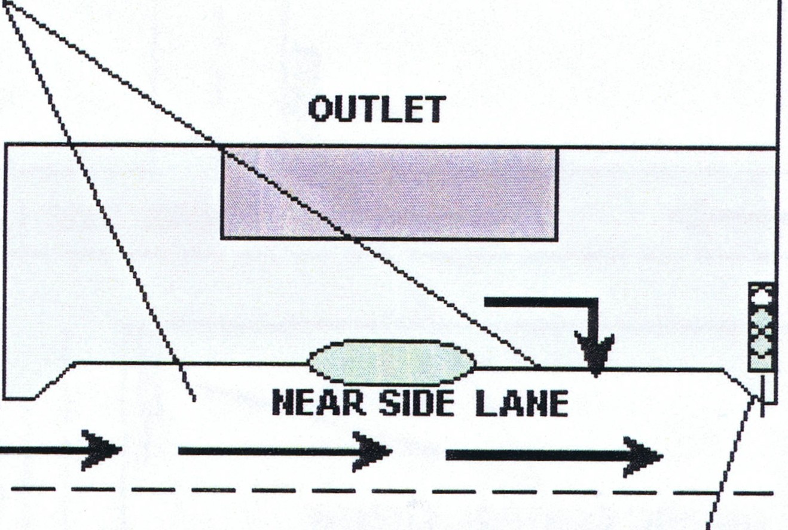ii!.

__
>

CONFIDENT/AL AND PROPRIETARY 39

Visibility: The visibility rating measures the distance from which a motorist or pedestrian can first recognize the presence of the store from the near side of the primary street. The following descriptions may serve as a guide.

Rating
1
2
3
Distance
Below Average: Under 39 meters Average: 40 -70 meters
Above Average: Over 71 meters

Appearance: Measures general housekeeping of the external appearance, cleanliness, and attractiveness of building, exterior, and grounds (parking lot). The store appearance rating should be compared to its own facility type (for example, compare a convenience food store to another convenience food store, compare a liquor store to another liquor store). Attributes to consider include:
  - Lighting
  - Level of rust
  - Overall building condition

Rating
1
2
3
Description
Below Average: An outdated facility that is poorly maintained . Average: An outdated facility that is well maintained .
Above Average: An outstanding facility, by all industry standards.

Cleanliness: Measures general housekeeping, cleanliness, and attractiveness of the inside of the store, trash cans and back counter. Attributes to consider include:
  - Lighting
  - Neatness
  - Cleanliness of floors and walls
  - Cleanliness of register area

Rating
1

2

3
Description
Below Average : An outdated facility that is poorly maintained. Unpolished floors, spills on counters, floors, or equipment.
Average: A facility with average cleanliness or a new facility that is poorly maintained.
Above Average: A modern facility that is well maintained. A facility that is superior in cleanliness and appeal, by all industry standards.

Clerk Service: Measures the services and courtesies provided by store personnel. Attributes to consider include:
- Speed of the cash registers when making purchases
- Behavior and attitude of store personnel
- Is the customer greeted with "May I help you?"
- Appearance of store personnel, including neatness and cleanliness of uniforms
CONFIDENTIAL AND PROPRIETARY 41

Rating
1

2

3

Description
Below Average: Merchandise is askew or out of line. Shelves are too high or shelf depth is too deep for the average customer to easily reach displayed items.
Average: Shelves are generally neat and orderly and within reach for the average customer. Merchandise displays are average in appearance.
Above Average: Displays are extremely precise, tidy and aesthetically pleasing. Shelves are located in positions that are convenient for customers and merchandise is attractively arranged.

Out of Stock Items: Measures the store's level of inventory and availability of merchandise. Inconsidering this rating determine if shelves are stocked sufficiently and inventory is pushed to the front of each shelf.

Rating
1

2

4
Description
Below Average: Customer would perceive the stock level to be insufficient or items are not pushed to the front. Quite a few items are out of stock or shelves appear to be empty.
Average: All merchandise is on display, and stock levels appear to be average and most merchandise is pushed to the front.
Above Average: All merchandise on display has sufficient stock levels to meet customer demand. All shelves are fully stocked and most shelves are pushed to the front.

Note: Because we are rating stores that rangefrom convenience food stores to supermarkets, it is impossible to state a specific number of items that would deem the store either below average, average or above average stock. If we set
an arbitrary number of items that would imply an average rating for out of stock; for example 10-15 items are empty = '2' or average, this will create the
following problem. A supermarket carrying thousands of items would be rated against a conveniencefood store carrying only hundreds of items.

CONFIDENTIAL AND PROPRIETARY 43

Perishable

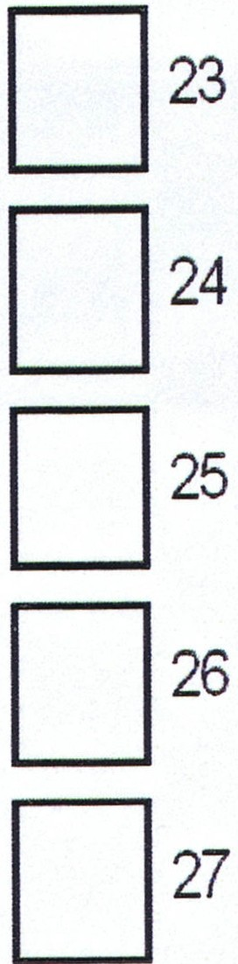
16. Perishable
(# of items)
0 N/A
- Below Avg.
- Average
- Above Avg.
Veggies/Fruits
(5 items each)
MeaUFish
(5 items each)
Dairy Products (50 items each)
Deli
(15-20 items)
Cooked Noodles
(excl. frozen food) (5 items)

Measures the store's product line emphasis, determined by freshness for food items and quality of stock.

Enter 0 for items not carried by this store.

Veggies/Fruits:

Rating
1

2
5

Meat/Fish:

Rating
1
Description
Below Average: Less than five vegetable and/or fruit items available or any single item in the case is not fresh.
Average: Five to ten vegetable and/or fruit items are available.
Above Average: All items are fresh and displayed in an appealing manner. There is a large selection (greater than ten) of vegetables and/or fruits.

Description
Below Average: Less than five meat and/or fish items are available or any single item in the case is not fresh.

  - Average: Five to ten meat and/or fish items are available.
  - Above Average: All items are fresh and displayed in an appealing manner. There is a large selection (greater than ten) of meat and/or fish items.

Meat or fish items that are vacuum packed should be included in the perishable rating.
CONFIDENTIAL AND PROPRIETARY 45

Dairy Products:

Rating
1

2
3

Deli:

Rating
1

2

3
Description
Below Average: Less than forty fresh dairy product varieties are available or any single item in the case is two days past the marked product dates.
Average: Forty to fifty fresh dairy product varieties are available .
Above Average : All items are fresh and displayed in an appealing manner. There is a large selection, greater than fifty, of fresh dairy product varieties and all cartons or packages are within the marked product date.

Description
Below Average : Less than twenty delicatessen product varieties are offered.
Average: Twenty to thirty delicatessen product varieties are available.
Above Average: More than thirty delicatessen product varieties are offered.

Cooked Noodles:

Rating
1

2
3
Description
Below Average : Less than five cooked noodle items are available or any single item in the case is not fresh.
Average: Five to ten cooked noodle items are available.
Above Average : All items are fresh and displayed in an appealing manner. There is a large selection, greater than ten, of cooked noodle products available.

CONFIDENTIAL AND PROPRIETARY 47

1BA. Number of Parking Spaces

18A. No of Parking Spaces
I I I I
32 33 34

Enter the appropriate number of parking spaces convenient to the store that is dedicated to the store consumer.

- Include parking spaces marked with painted lines or raised concrete markers.

- When parking spaces are not marked, estimate the number of spaces dedicated to the store.

- Ifthe store is located in a shopping center, count only those parking spaces directly associated with the store and exclude parking that would be used by other retail establishments.

- Do not include pedestrian walk area as parking spaces.
paces

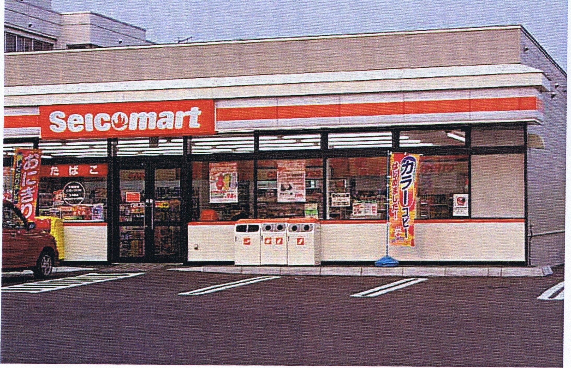
Marked Parking S
----------------------
- Some parking spaces may be especially designed for truck parking. These will be larger marked spaces to accommodate trucks. Count each of these spaces as only one parking space each. See below picture.

CONFIDENTIAL AND PROPRIETARY 49

Discount Food Store

CVS  Parking = 4 | Parking = 6
Drug Store  Parking = 24 | CVS  Parking = 4
Liquor Store

Parking = 0
Home Center  I  11 1 1 1 1 1 1  11 11 11 11  Parking = 44 | Supermarket  I I  1 1 1 11 11 11  11 11 11 11 1  Parking = 32

CONFIDENTIAL ANO PROPRIETARY 51

...........
188. On-street Parking

Impossible Rarely Available
Sometimes Available
Always Available
0 1-35
02
0 3
04
<RO>
·..·..·..·..·..·..·..·..·..·..·..
t·....·..t·...·..2·...·..·...·t.·..t·...·...
:.:.::.::.::.::.::.::.::.::.::.:
:..:..:.:.:.:.:.:.:.:.:.:.::..:.::..:.:.::.:.
.....................
2) Rarely Possible

.!!!!.! 1. !!!.!
......................
......................

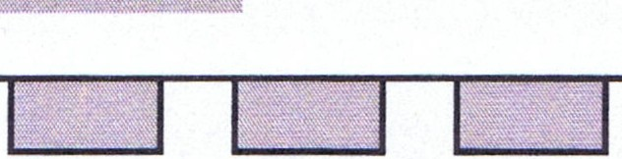·.·.·.·.·.·.·.·.·.
1) Impossible

............
!i!!!!!!!]!!!i!i!!!i!
..··..··..··..··..··..··..··..··..··..··..··..

?..?..m....t.


·.·..·.-.........·..........
:......:..:.::.:.:.:..:.:.:.::.:.:..:.:
·.·..·.··.····.....·...·
lllllll!l!Ji/:/ /
4) Always Possible
·········
..................
}}]}
..................
:.:.:.:.:.:.:.:.:.:.:.:.::.: =.::.:.:..::..:
:::::::::::::::::
3) Sometimes Possible
CONFIDENTIAL AND PROPRIETARY 53

Entrance to Lot (Barrier to Traffic Crossover)

Consider only auto traffic when rating access/entrance to the lot.

19. Entrance to Lot
Impossible
Access Front
Access Side
Possible
0 1-36 0 2
0 1-37 0 2

Check "Impossible" if the store is not accessible from the primary or secondary streets.

Check "Possible" if the store is accessible from either the primary or secondary streets.

If t store is located on a street with either a full or partial barrier, this could make access to the store difficult or impossible.

  - Full Barrier - A raised central barrier, divider, or other physical barrier that prevents traffic crossover from the opposite side of the street and affects all curb cuts permitting access from that street. Ignore ineffective barriers that are not true medians, such as a ten-centimeter high-raised strip.

OUTLET

_P_r_uMAR_v_s_T .I__ f c===J -'--------.------
NEAR SITE LANE(S) _./
ozz;;;;;;; ;;;??777777::.=;;zz zz;7 zz 7 zz zz zz zz ;;??777 ;;;; 1 zz z zzzp

CENTRAL B7ARruER

TRAFFIC IN FAR-SIDE LANE(S) UNABLE TO ACCESS OUTLET
""
DUE TO FULL CENTRAL BARruER

  - Partial Barrier - A Barrier exists that affects only one curb cut.
_P_R_lM_A_R_v_sT_ .I_ _) :J_.'---- --..------
OUTLET
..CZ Z ZZ Z ZZ Z Z?Z?ZZZZZZZZZZZZ ZZZZ Z ZZ> c/ZZZZZZZZZZZZZZZZZZZZZZZZZZZ>

CENTRAL BARruER

CONFIDENTIAL ANO PROPRIETARY 55

Type 4 Transient

Leave Blank.

MPSI Code

Leave Blank.

Type Special

Leave Blank.

Panel Number

Leave Blank.

Average Daily Traffic Count

Leave Blank.

Trade Area Override

Leave Blank.

Company Outlet l.D.

Leave Blank.

CONFIDENTIAL AND PROPRIETARY 57

Indicate any unusual circumstances about this store. Additional comments.

Use this space to further describe the store or to respond to any of the form questions that may require more detailed explanation .

Also, report any conditions that have influenced the store's sales volume performance . Inparticular, give conditions during the past year that are no longer present, store and location changes within the last year, and temporary or seasonal conditions. Here are a few of the kinds of conditions that could influence sales volume:
    - A large amount of commercial business (50% or more)
    - Road construction impeding access (or a new road)
    - Promotions stopped (or expanded)
    - Pricing changed from high to competitive (or vice versa)
    - Changes in hours or days open
    - Longtime manager (or new manager)
    - Remodeled facility
    - Conversion to different type store
    - Summer tourism

Try to provide the approximate date when the change took place or the months during which the unusual condition prevailed.

CONFIDENTIAL ANO PROPRIETARY 59

Manual Traffic Count

Time of Count: Report the beginning time of each 15-minute count in the START column. Report the ending time of the 15-minute count in the END column. If you need to take two subsequent counts due to exceptionally busy traffic, note the first interval as the time of count.

NOTE: All times used to report the traffic count start and end time MUST be in the "24 Hour" format . For example, use 15:30 instead of 3:30 P.M.

Day of Week: Check the day of week you took the traffic count.

Traffic Counting Procedures City Retail Outlets

At all retail outlets, two 15 (ten) minute counts must be taken, one at peak and one at lean time. This will allow the counters to pick up any significant differences between the traffic patterns that may arise as a consequence of the hour the traffic is tallied.
-+ Do NOT count traffic before 08:00 OR after 20:00. If you take one count in the peak times (07:00 to 9:00 and 17:00 to 20:00), the other count MUST be taken outside of these time intervals (lean period). Do NOT count traffic on Saturday, Sunday or on Public Holidays.

Tally the counting in three distinct categories:

- PETROL & DIESEL: Number of vehicles that fit the Petrol and Diesel
category, including private cars, police cars, ambulances, and small vans, trucks, jeeps, taxis and buses.

- 2 WHEELERS : Number of 2 wheelers, which include all scooters and
motorcycles .

The counts must cover the entire span of the primary street.

If the primary street has two-way traffic, count both at the same time. This is the standard procedure, even if there is a full barrier in the primary street.

If the primary street is exceptionally busy at the time of the counting and there is great difficulty in assuring the quality and consistency of the counts, two 15 (fifteen) minute counts have to be taken, one for each traffic direction and added before filling the appropriate boxes in the Traffic Counting form. If you need to take two subsequent counts due to exceptionally busy traffic, note the first interval as the time of count.

In the event the traffic has come to a standstill and your observation of the problem indicates that the solution will take too long (above five minutes) you should NOT wait for the traffic jam to clear. You can also try to move further along the street and try to
CONFIDENTIAL ANO PROPRIETARY 61

Survey Wrap-Up:

- Turn in all completed forms.

- Submit SmartMedia card.

- Turn in a Photo Log for each SmartMedia card.

- Submit the following:

- Store list

- New store form (pink paper)

- Overlapping RO

- Existing Store RO

Please check RO's with the photo list and ensure they are stamped on the upper right before turning in.

If there are any inconsistencies or errors in the form the Survey Supervisor will be contacted, if the inconsistency can not be rectified a re-survey of the store will be required.

CONFIDENTIAL AND PROPRIETARY 63

