**TABLE OF CONTENTS**

LOG IN 1

MOVING AND ZOOMING IN /OUT ON MAP 2

CHANGING MAPS 2

STORE INFORMATION: LABELS, SQUARES AND DISPLAY 3

SELECTING A STORE 4

EDITING AN EXISTING STORE 4

CREATING A NEW STORE 6

VIEWING A PHOTO 10

UPLOADING A PHOTO 11

RELOCATING AN EXISTING STORE 12

EVALUATIONS RATINGS 13

LOG IN

To login into the BCG Analyzer, double click the BCG icon on the desktop.   
  
The following screen will appear:

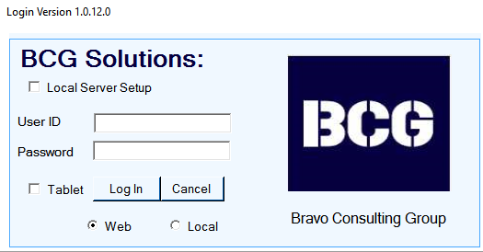

You need to use the following credentials:

User: seico1

Password: S31c11*

You must choose the option local, as you are working locally in a citrix environment.

Once you have entered the user id, password and have selected local, you can proceed and click the login button.

At that point the BCG application will open and you will be able to see the map and stores in Hokkaido.

This simple menu will show you the basic operation of the BCG Analyzer software that you will use to collect the data for all the stores in your designated area.

NAVIGATING AND ZOOMING IN /OUT ON MAP



MOVING ON THE MAP: you can move within the map when you click, hold, and move.

ZOOM IN / OUT: you can zoom in/out by:

1. Using the mouse wheel
2. Double clicking the map left click zooms in and right click zooms out.
3. Using the zoom bar on the left:

CHANGING MAP TYPE

There are two maps available for your use:

* Open Street Map
* Bing Hybrid Map

To change the system map follow the steps below:

1. Select the Map category in the main menu.

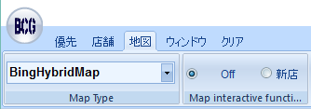

1. Select the type of map you are going to use.

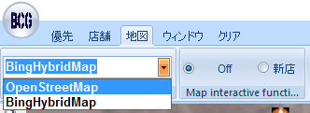

MAP INFORMATION: LABELS, SQUARES AND DISPLAY

DISPLAY LABELS: You can choose to see all labels at the same time, which tell you the store (store) Id and the store name by selecting the label display checkbox

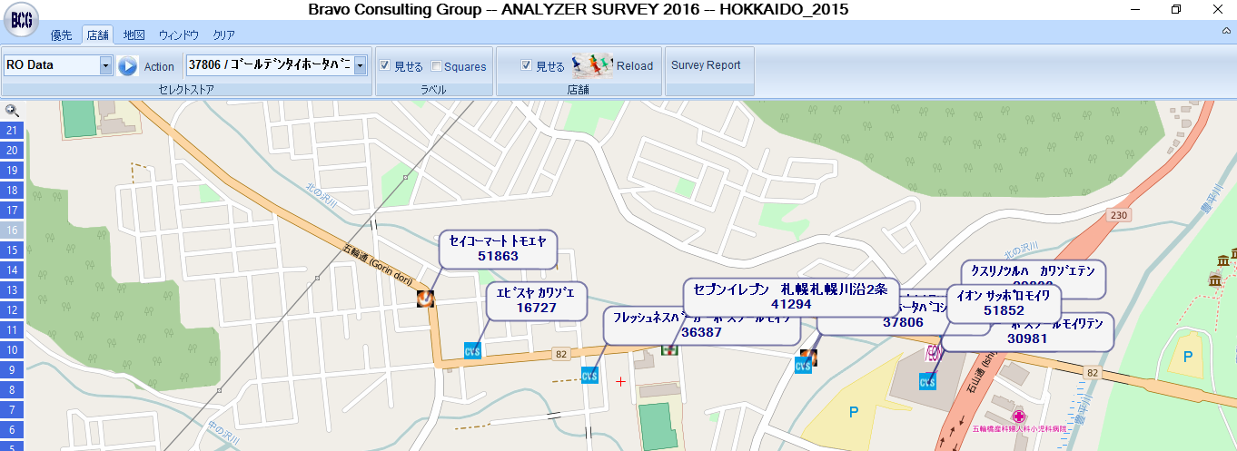

SQUARE LABELS: You can choose to see all square labels at the same time, which tell you the store (store) Id and the store name by selecting the square label checkbox.

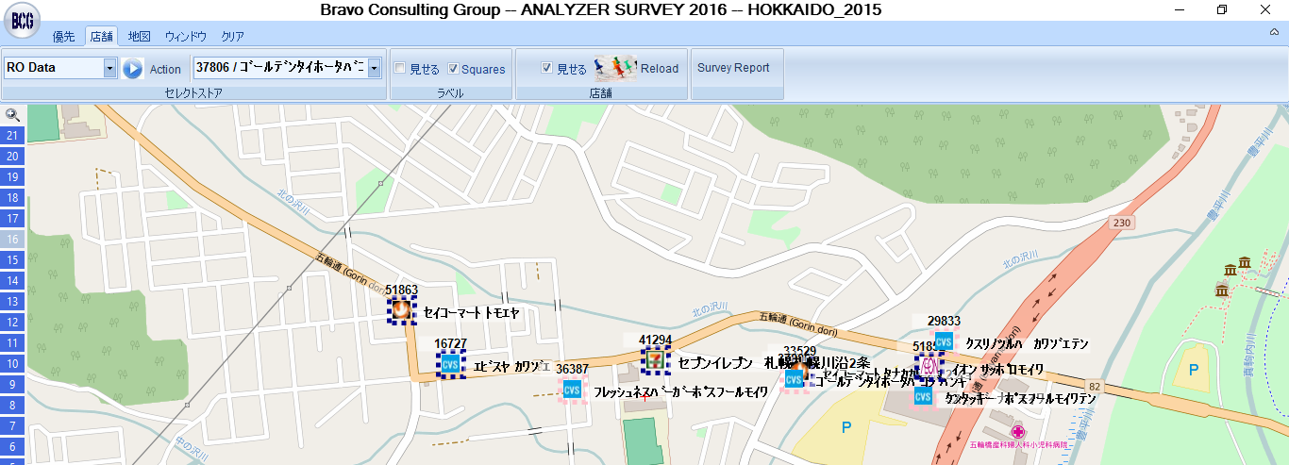

STORE (Store) DISPLAY: You can remove the stores logos by unselecting the store display checkbox.

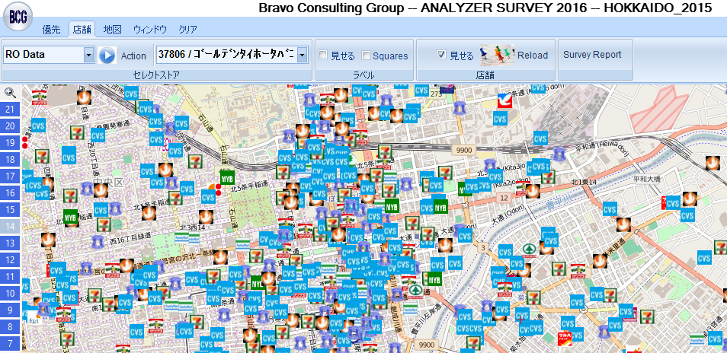 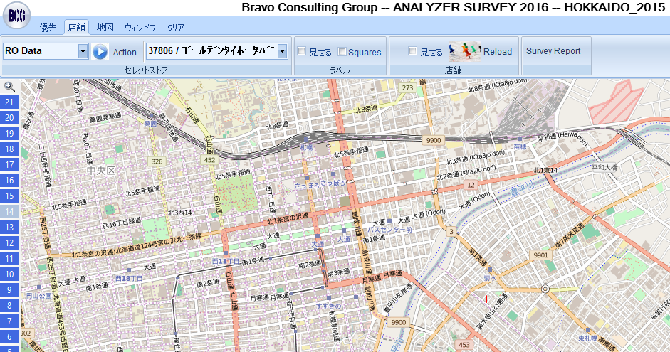

SELECTING A STORE

You can select o place a store in the center of the map by:

1. Typing the NAME of the store in the dropdown list in the store menu.
2. Typing the STORE ID of the store.
3. Searching for the store in the dropdown list.

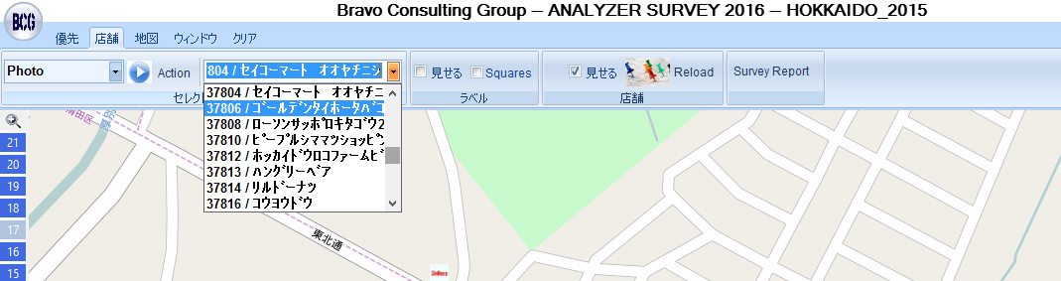

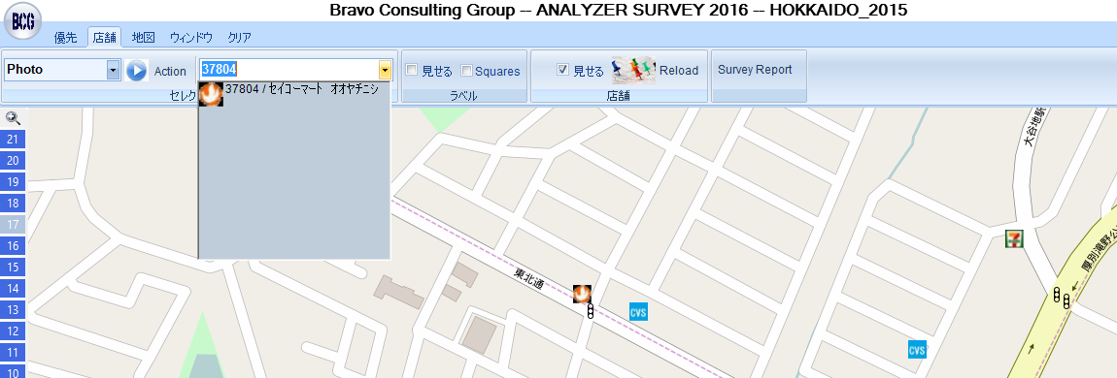

EDITING AN EXISTING STORE

1. In the store menu select or type the STORE ID or STORE NAME and select the store you want to edit. The program will position the store selected in the center of the map.

Or You can manually locate the store in the map.



1. Select RO DATA on the Action dropdown list and then click on the store logo. Or right click in the store logo and select DATA.

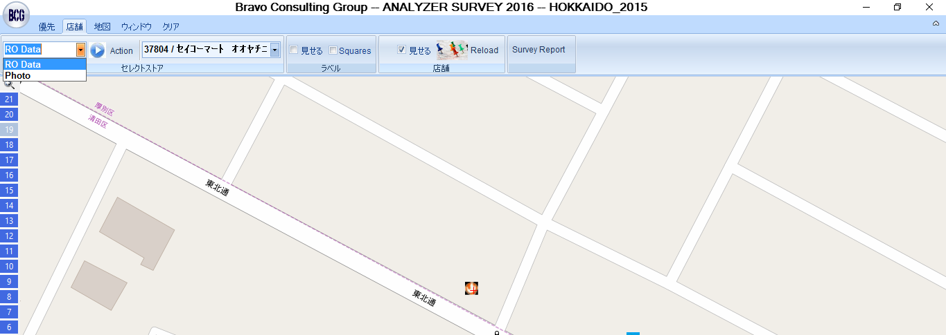 or 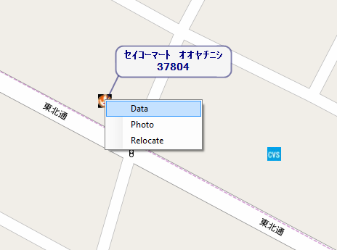

1. Wait for the data entry form to appear and edit the data you want to change.

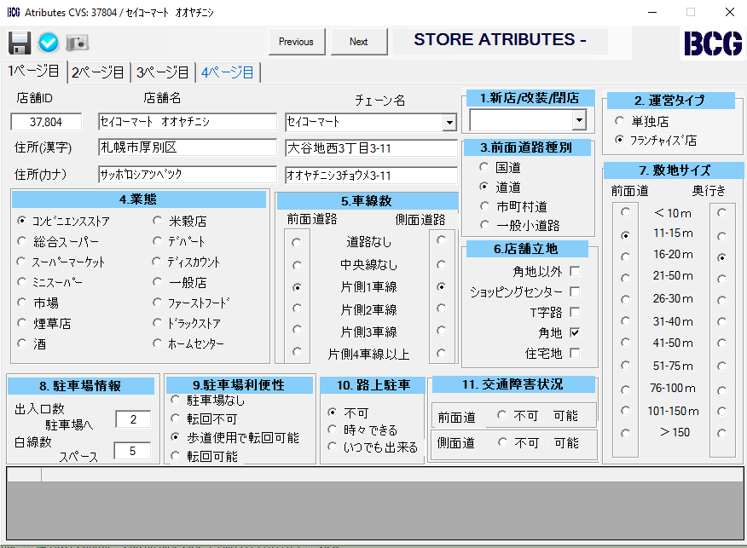

1. Press the Save Bottom and your new STORE is now created.

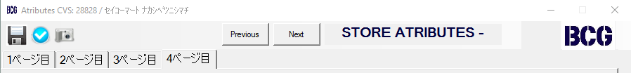

** If you do not press the save botton before exit the following message will appear:

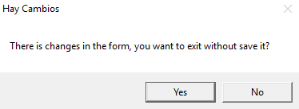

If you select Yes, the changes you made will not be saved.

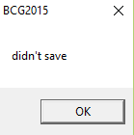

CREATING A NEW STORE

1. Select the Map category in the main menu.



1. In the Map Interactive functions select New Store.

(to undo the New Store command select Off)

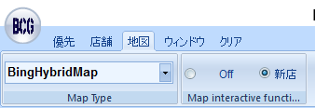

1. Locate your mouse pointer in the exact location where the new STORE will be located and press right click. Wait for the form to appear.



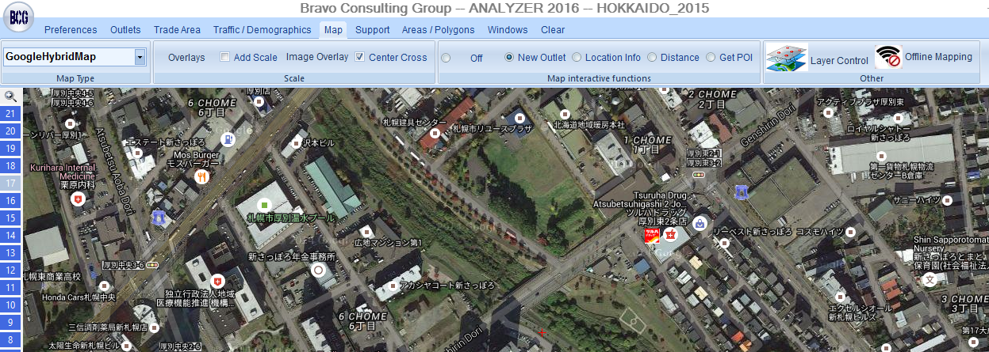

**(right click )**

1. Wait for the data entry form to appear and introduce all data related to Location and Parking.

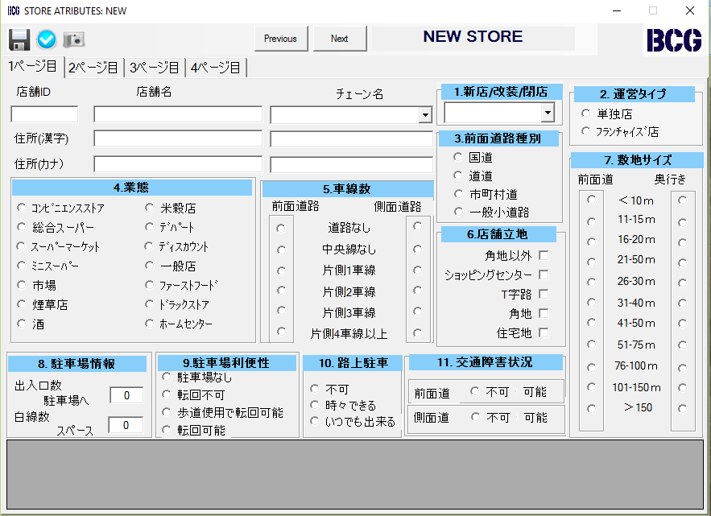

1. Introduce all data related to Operating Hours, Facilities, Price and Traffic.

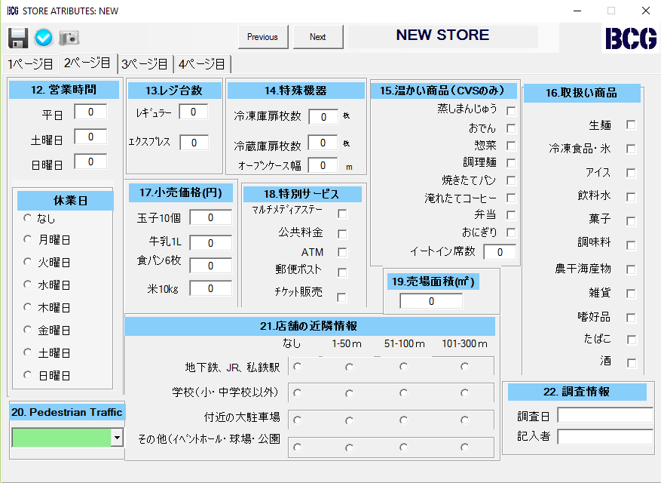

1. Introduce all data related to Display Size

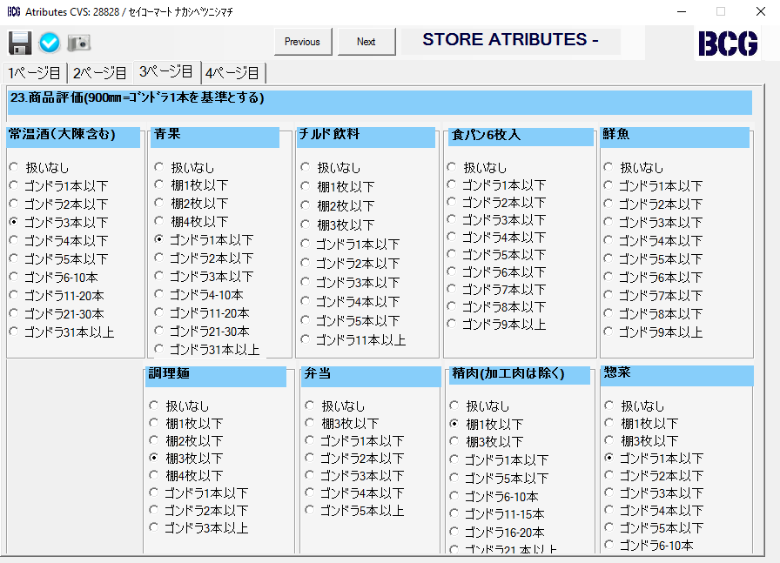

1. Introduce all data related to Ratings

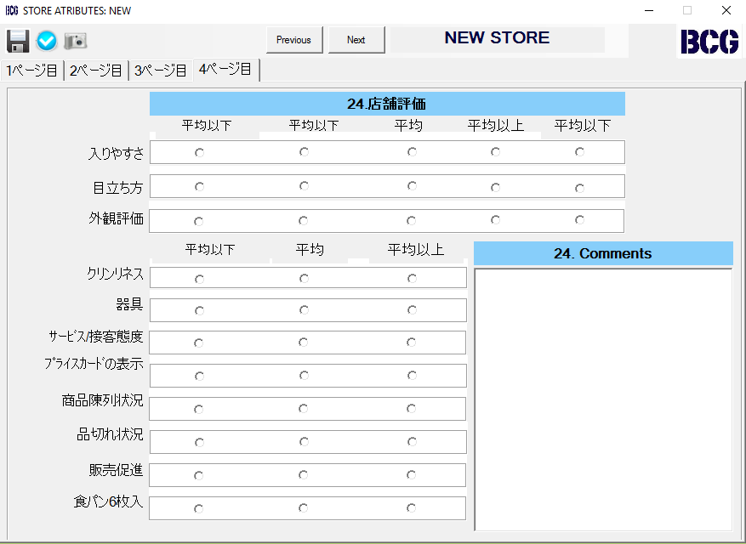

1. Press the Save Bottom and your new STORE is now created.



** If you do not press the save botton before exit the following message will appear:



If you select Yes, the changes you made will not be saved.



VIEWING A PHOTO

There are two ways to view a photo:

1. Select from the dropdown list in the Stores category the “Photo” option.

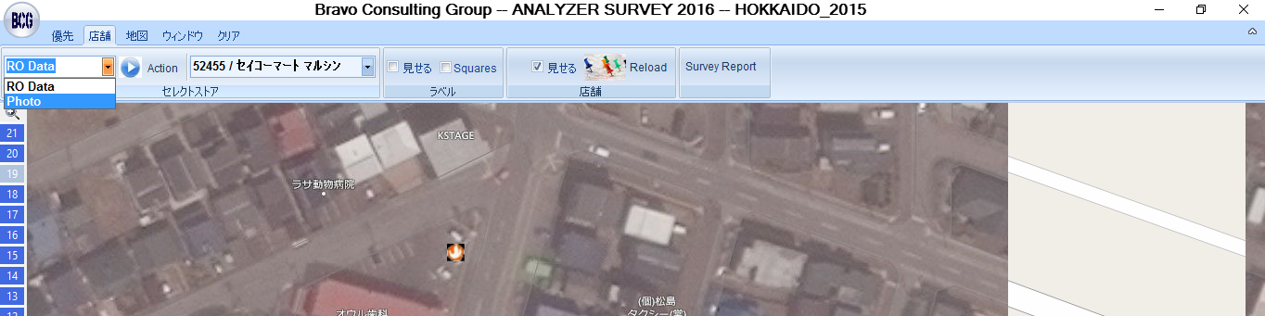

1. Use the right click and select “Photo” in the STORE that you want to see the picture.

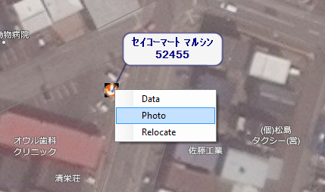

UPLOADING A PHOTO

Start by saving the file as follows: BCG Id Letter.jpg (ex: 52455B.jpg Use letter A for the first Picture, B for the second and so on)

1. Select from the dropdown list in the Stores category the “Photo” option, or right click and select “Photo” in the STORE that you want to upload the picture.



Or use right click:



1. Press the Open File button

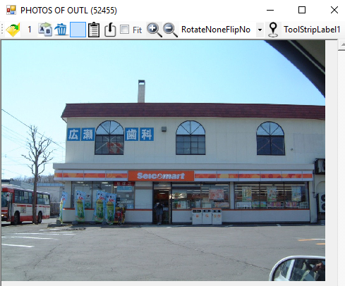

1. Open the file to be uploaded

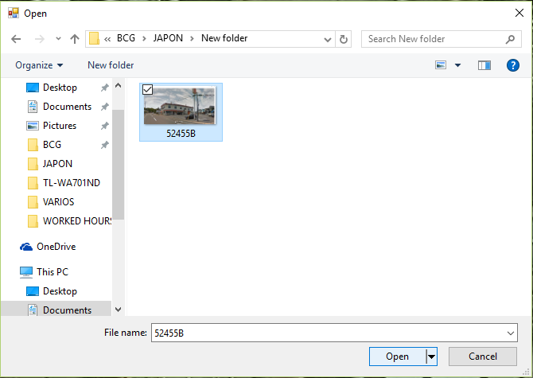

RELOCATING AN EXISTING STORE

1. Right click on the STORE to be relocated and select “Relocate”

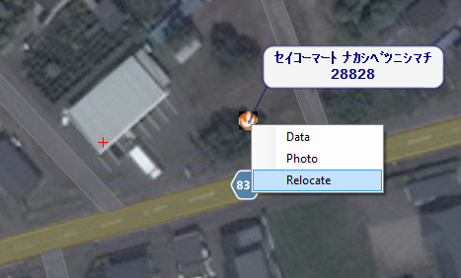

1. Right Click on the exact place to relocate the STORE.

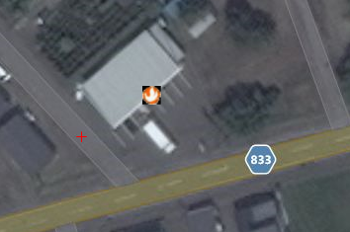

EVALUATIONS RATINGS

**Accessibility Rating:**

The accessibility rating measures the ease of entry and exit primarily for motorists on the store side of all accessible streets. The assumption is that consumers want to continue to travel in the direction they were originally going to when they pulled off the street into the store's driveway.

This evaluation is measured driving on the main street of the store in the lanes that access the store.

**Poor**: In this category we include stores that have no access to the store and stores that have the worst access in the market. Typically in this category we include approximately 5% of the stores.

Most stores with poor accessibility have:

1. Small front – less than 15 meters
2. Only one entrance
3. Impossible to turn in lot. Typically cars have to back out of the store
4. Difficult to get back to the main street traffic

**Below Average**: is given to stores that have accessibilities that can be less favorable than the majority of the stores.

Most stores with poor accessibility have:

1. More than two store-side traffic lanes making it difficult to cross the traffic flow to access a store.
2. High traffic counts on Primary Street (over 20,000 cars per day).
3. Store that have impediments, like bad pavement on upward or downward slope in the entrance.

**Average**: Most stores have average accessibility or reasonable ease of entry/exit for motorists on the store side of the street.   
  
Most stores with average access have:

1. Two traffic lanes on the store side of the primary street.

2. Average traffic counts (between 10,000 and 20,000 cars per day) and speed (70 kilometers per hour) on the primary street.

3. Two curb cuts or a continuous driveway on the primary street.

4. Average front size higher than 20 meters.

**Above Average**: Above average access is unusual, but it exist when a store has a clear advantage over competitor stores. A combination of the factors below could increase accessibility relative to competition.

1. One store-side traffic lane
2. Long gradual access to store.
3. Low traffic counts.
4. Two curb cuts or a continuous driveway entrance on all streets.
5. Large lot size

**Superior**: In this category we include stores that have the best possible access in the market.

Most stores with average access have:

1. One store-side traffic lane
2. Long gradual access to store.
3. Low traffic counts.
4. Two curb cuts or a continuous driveway entrance on all streets.
5. Very large lot size
6. Ability to comfortably make a turn in the parking lot.

**NOTE:** Heavy traffic is a serious impediment to accessibility. The following are negative factors for accessibility:

3. Traffic interference, such as dedicated right-turn lanes.

4. Sharp triangular shaped lots.

5. High-speed traffic.

1. Poorly positioned traffic control signals leading to congestion.
2. Forced exit layout where access to the store is limited to one street and exit to another.

8. Temporary disturbances, such as road construction, cars parked on site, etc.

**Visibility Rating:**

The visibility rating measures the distance from which consumers can first recognize the presence of the store while driving on the primary street. Keep in mind a bell curve type distribution of this rating is desired. Although most stores have average visibility, obstructions such as buildings or trees may justify a lower rating. A store that lacks a brand sign should be given a below average rating.

The most important factor on visibility is how far ahead can you see the store while drivng on the main street.

Factors that may affect visibility:

1. How far can you see the store signage
2. How far can you see the actual store
3. Are there trees impeding the vision of the store

**Building Appearance Rating:**

*Appearance:* This item rates the condition of the image of the store. The items that influence this score are:

* Physical appearance of the building
* How old the store is. Older stores the worse the look, if they have not been renovated
* Condition of the parking space paint
* Condition of the pavement
* The area were the store is located can also influence the store appearance.

When rating a store’s appearance, compare it to facilities across the entire market; that is, compare service stations to service stations, pumpers to pumpers, etc. Recommended ratings:

**Rating Description**

**Poor:** These are stores that have outdated facilities that are poorly maintained.

**Below Average** A modern facility design that is no longer being used by the brand for new stores, or a recent rehab

**Average** Most of the stores (60%) fall under this category

**Above Average** Stores that look better than the average. They typically are relatively new stores that are very well maintained.

**Superior** Newly constructed stores with very nice looks.

**NOTE:**  A store must have the company’s newest image to qualify for an appearance rating of 5.

SURVEY TERRITORY

Surveyors can choose the Survey Territory options to see the stores that are in their territories.

To access it click on Survey Report

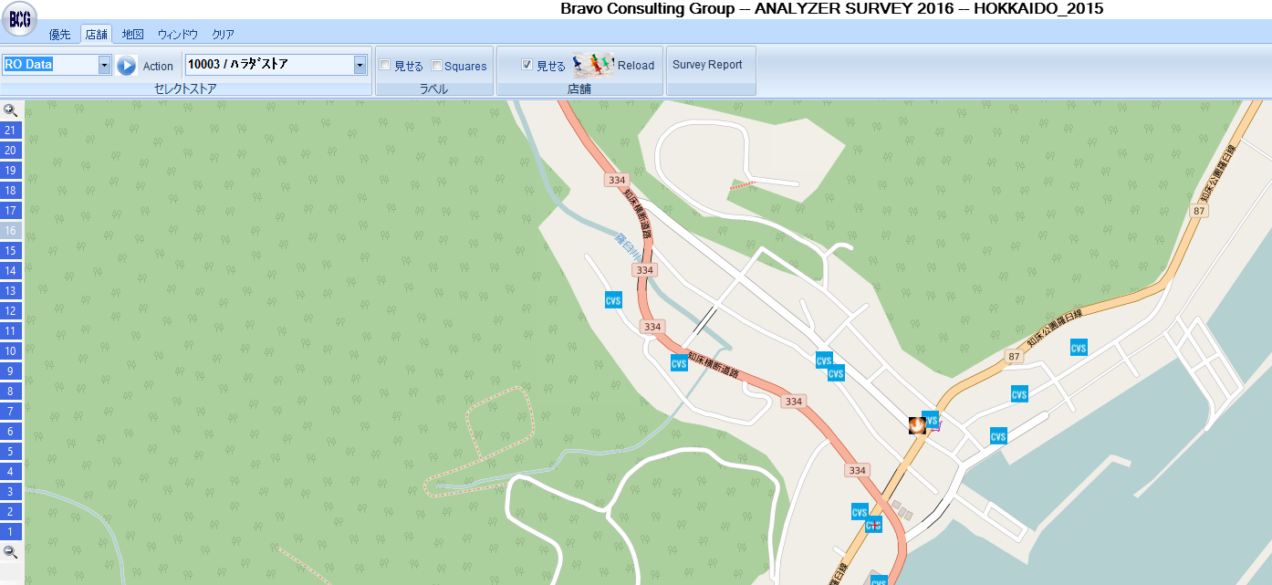

You will get the map of your survey area:

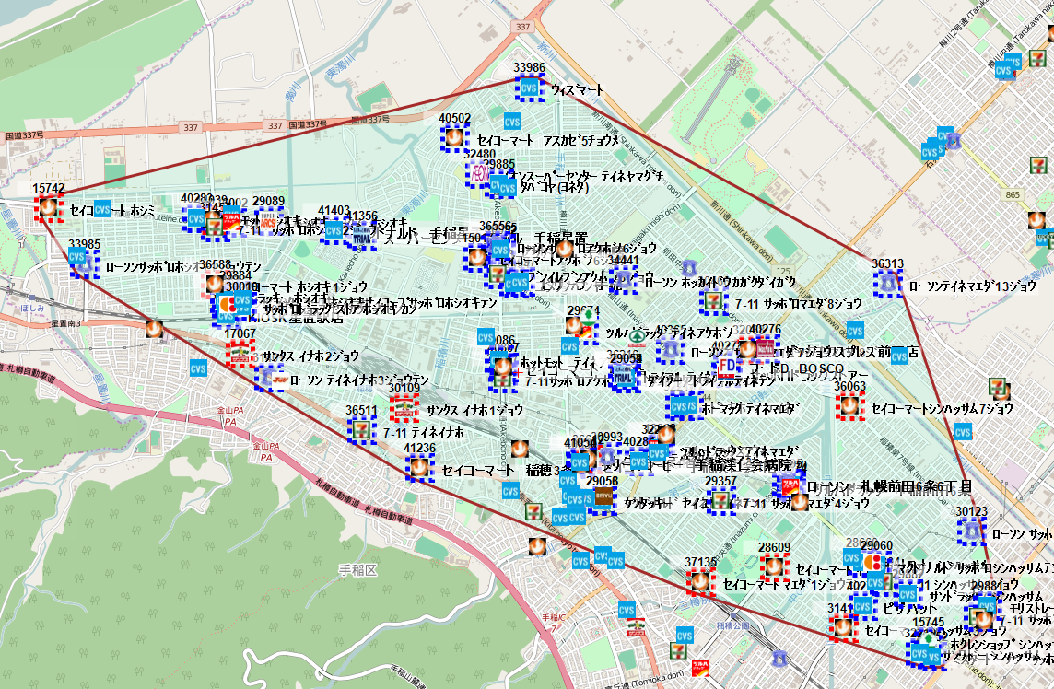

The squares in red indicate stores that have not been surveyed yet.

The squares in blue are the stores that have been surveyed.

You will also get the following report:

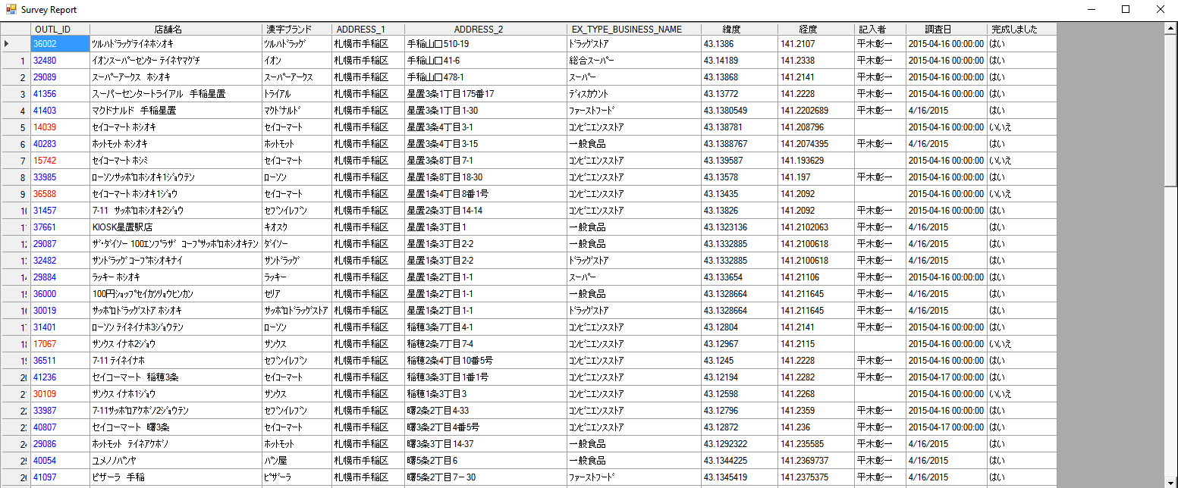

Again, the red and blue matches the squares on the map.

You can also right click a store on the report and you will have the optios to:

1. See stores photo, if it exist
2. Get the data report for the store
3. Center the map on the store